CNT360 Fully Automatic IHC & ISH Staining System
Regularly clean and maintenance schedule
The user should perform the regularly clean and maintenance according to this table.
Task
Daily
- Check large waste containers are no more than half full. Empty them before overnight run.
- Check large reagent containers are at least half full. Fill them before overnight run.
- Clean the slide staining Unit (after each batch, including the heaters and theirs around)
- Clean the slide trays (after each batch)
- Clean liquid covers, suggest discard it after being reused up to 25 times (after each batch）
- Close client software and open it again.
Weekly
- Restart the processing module (power off the processing module and host computer, wait 30 seconds, then turn on)
- Wipe the robotic arm aspirating probe from up to down with 75% alcohol.
- Clean the reagent platform.
- Fill full the buffer solution, alcohol solutions and DI water.
Monthly
- Replace the mixing station (based on the utilization rate of 60 slides per day, if more or less, change the frequency accordingly)
- Check and clean all large containers.(Check if there are impurities,precipitation,odor inside before refilling.If any, clean and refill)
- Check and clean slide label printer, ensure the labels are enough, print normally.
- Check syringes, there should be no leakage of the syringe, no cavity or bubble during movement.
- Wash the aspirating probes by the reagent cleaning kit
When necessary or least a year
- Replace the aspirating probes of the robotic arm.
- Replace the syringes

The below information shows the standard operation procedure of some maintenance items.

1. Cleaning liquid covers
1.1 Soak in 5% bleach solution for at least 10 minutes.
1.2 Soak in Distill water for 10 minutes.
1.3 Soak in absolutely alcohol for 10 minutes：
Dry with a lint free cloth, or Dry by airing.
1.4 Carefully check the liquid cover surface for debris, cracks or deformation. If there is any damage, discard it. Or replace a new one.

2. Cleaning slide tray
Clean the slide tray with a 70% alcohol solution.

3. Cleaning reagent tray
Clean the reagent tray with 70% alcohol solution, and then air dry or wipe dry it.

- Clean the slide staining unit
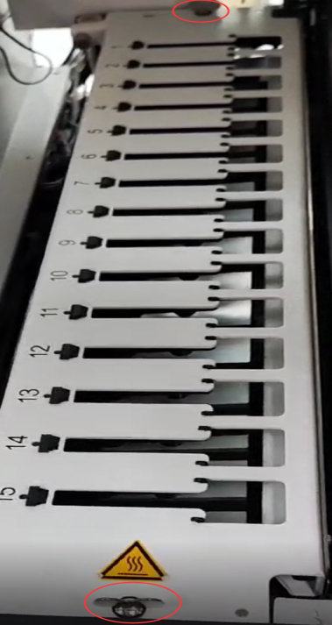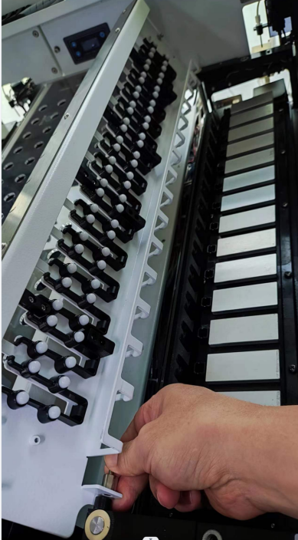
Figure: unlock the twist tabs, open the top plate and release the lock fasteners
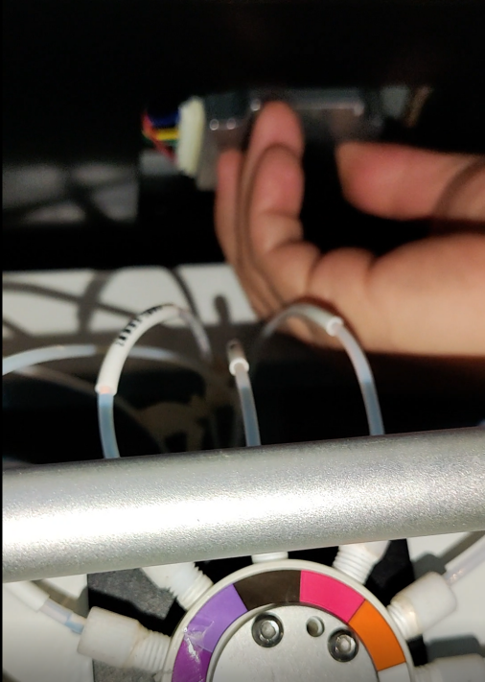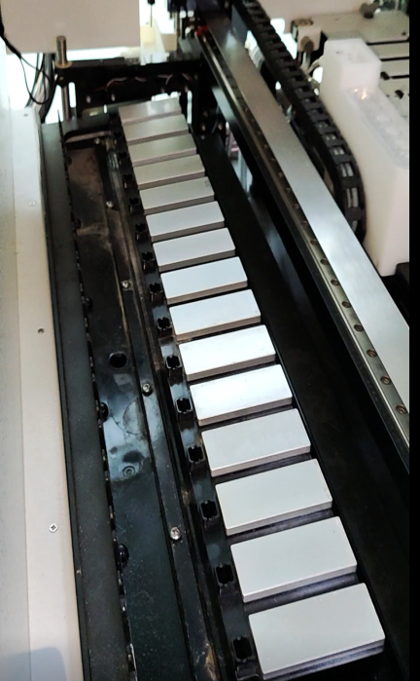
Figure: anticlockwise rotate the release knob to move the drag board to full position
（1）Ensure the device is idle and power off the device, disconnect the power cable.
（2）Open the top plate, remove the top plate, manual release the drag board to full position (refer to the above picture).
（3）Use a lint-free cloth moistened with 70% or higher gradient alcohol to
clean the heater pads，drainage ports , the drip tray around the pads, and the
surroundings.
（4）after finishing the cleaning, please ensure the top plate locks to be tightened properly.

5. Clean the instrument surface, door and covers
Use a lint-free cloth moistened with 70% or higher gradient alcohol to clean the
Surface, doors or covers.

