

CNT360-M1
Fully Automatic IHC Staining System
User Manual
V1.0.2

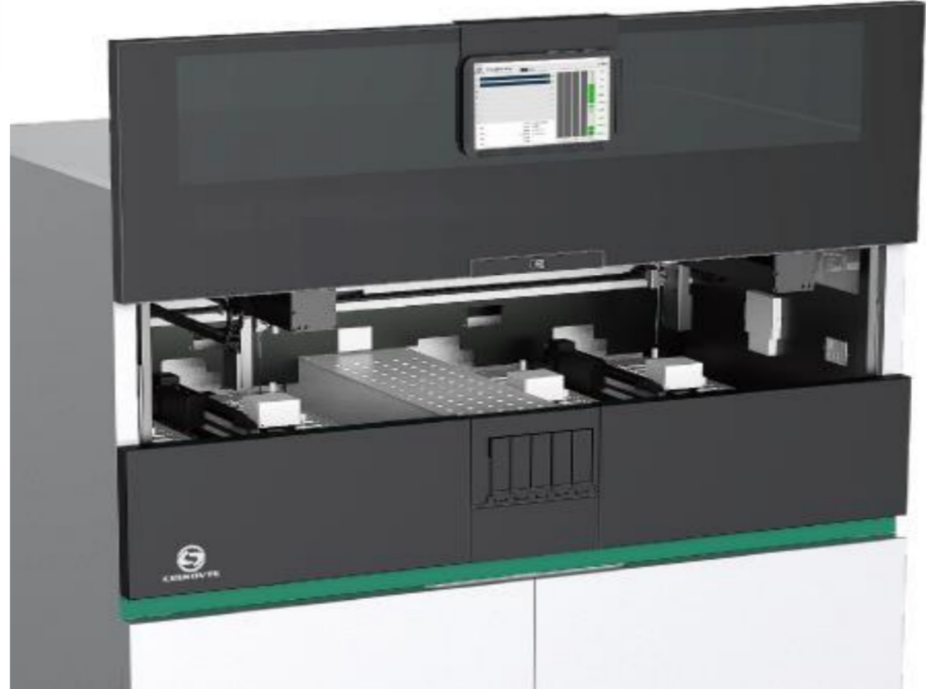

Henan Celnovte Biotechnology Co., Ltd.

Contents
1. Safety Precautions 9
2. Overview 12
2.1 Model 12
2.2 System overview 12
2.3 Initial steps 12
2.4 Daily operation procedure 13
3. Hardware 16
3.1 General description 16
3.2 System components 16
3.3 Processing module 16
3.3.1 Initialization of the processing module 18
3.3.2 Instrument cover 19
3.3.3 Robotic arm and Scanning module 19
3.3.4 slide staining unit 20
3.3.5 Slide heater 21
3.3.6 Liquid car 22
3.3.7 Front panel 22
3.3.8 Large container cabinet 23
3.3.9 Aspirating probe 25
3.3.10 Washing area and mixing station 26
3.3.11 Power switch 26
3.3.12 Control panel 26
3.3.13 Cooling module 27
3.3.14 Heating module 27
3.4 Host computer 27
3.5 Slide label printer 28
3.6 Auxiliary devices 28
3.6.1 Slides 28
3.6.2 Liquid cover 29
3.6.3 Slide tray 30
3.6.4 Reagent tray 30
3.6.5 Detection system, reagents and open containers 31
3.7 Large container 32
4. Software 34
4.1 General description 34
4.2 Software startup 35
4.3 Notification, warnings and alarms 36
4.4 basic settings for Windows OS system 37
5. Status screen 40
5.1 System status screen 40
5.1.1 Hardware status 40
5.1.2 Protocol progress 43
5.2 Program status screen 44
5.2.1 Display slide properties 44
5.2.2 Display protocol execution steps 46
6. Slide management 47
6.1 Slide management screen 47
6.2 Use of control tissue 48
6.3 Case creation 48
6.3.1 Case control and active case information 49
6.3.2 Case identification 50
6.3.3 Add case 50
6.3.4 Case duplication 51
6.3.5 Edit case 52
6.3.6 Delete case 52
6.3.7 Copy case 52
6.3.8 Case report 52
6.4 Doctor list 53
6.5 Create slide 53
6.5.1 Description of slide fields and controls 54
6.5.2 Create slide 55
6.5.3 Copy slide 55
6.5.4 Edit slide 55
6.5.5 Delete slides 56
6.5.6 Manual identify and remove slides 56
6.5.7 Add slide template 57
6.5.8 Dispense volume and tissue position on the slide 57
6.6 Slide labels 58
6.7 Slide setup summary report 59
7.Reagent management 60
7.1 General description of reagent management 60
7.2 Reagent identification 61
7.3 Substitute reagent 61
7.4 Determine reagent volume 62
7.5 Reagent list details report 63
7.6 Reagent usage report 64
8. Operating protocol management 66
8.1 Protocol management Screen 66
8.2 Protocol Details 66
8.3 Creating a new protocol 67
8.4 Copy a protocol 67
9. Slide history screen 68
10. Running information 69
11 Other software operations 69
11.1 System management screen 69
11.1.1 Turning off the buzzer 70
11.1.2 Set slide label template 70
11.1.3 Perform the maintenance tasks 70
12. Cleaning and maintenance 71
12.1 Precautions 71
12.2 Cleaning and maintenance schedule 72
12.3 Aspirating probe 73
12.3.1 Clean the probe 74
12.3.2 Replace the probe 75
12.4 Slide staining units 77
12.5 Liquid cover clamp 80
12.6 Liquid cover 80
12.7 Slide tray 81
12.8 Protective covers and doors 81
12.9 Mixing station 81
12.10 Drip tray 81
12.11 Reagent tray 82
12.12 Large container 82
12.13 the waste liquid container 84
12.14 Robotic arm and scanning module 84
12.15 Slide label printer 85
12.16 Syringe 85
12.17 Disconnect the processing module 88
12.18 Restart the processing module 89
13. Technical parameter 90
13.1 Physical specifications 90
13.2 Electric 90
13.3 Environment 91
13.4 Operating Specifications 91
13.5 microscope slides 92
13.6 Transportation and storage 92
After-sales service commitment 93
Basic information 93

1. Safety Precautions
This manual and the information on the product label will contain all the information required for operation and maintenance.
Please note the emphasis, standard laboratory regulations and local laboratory management regulations. All cautions or warnings are listed in the table below.
Symbol |  | Explain
   |  | Note：Wear protective gloves when handling reagents and opening reagent containers. The reagent containers may tip during transportation, which may cause the reagent residue to adhere to the reagent cover.
 |  | Warning: During the use of the machine, some reagents (including potentially hazardous reagents) may accumulate around the slide staining units. When the slide trays are inserted or removed, these reagents may contaminate the slide trays. Although the risk is very small to the surrounding environment and employees, users should wear protective clothing and gloves when handling slide trays.
 |  | Warning: Clean spilled droplets with 70% alcohol. Do not put xylene, chloroform, acetone, strong acid (such as 20% hydrochloric acid), strong base (such as 20% sodium hydroxide) or other similar solutions close to the machine. If there is any overflow of such solution, it should be removed immediately. Xylene or other substitutes should not be used as dewaxing solution, it may cause some parts of the machine to be eroded, leading to solution leakage.
 |  | Warning: Users must understand local regulations and correct operation procedures when handling dangerous articles.
 |  | Warning: There is dangerous voltage inside the machine. Only the technical service persons approved by our company can open the protective cover of the machine or touch the internal components of the machine.
 |  | Warning: The working voltage of the machine has been set at the time of system installation and initial setting. No one is allowed to change the voltage except qualified technical service person. The machine must be connected to the grounded main power socket, and be positioned so that it is easy to disconnect the power supply cable for the user without having to move the machine.
 |  | Warning: The temperature of the slide staining units can be very high, cause severe burns. Do not touch the slide staining units or their surrounds within 20 minutes after the stop of operation.
 |  | Warning: Slide staining units and their surrounds, and slides in the slide staining trays may be very hot, which may cause serious burns if contacted. Do not touch the slide staining units until the software indicates that the temperature decreases. If the software is not running, wait at least 20 minutes after cutting off the power supply.
 |  | Warning: During the operation of the system, some reagents (including potentially hazardous reagents) may collect around the slide staining units. When the slide trays are inserted or removed, these reagents may contaminate the slide trays. Although the risk is very small to the surrounding environment and employees, users should wear protective clothing and gloves when handling slide trays.
 |  | Warning：  - The machine has an interlocks protection mechanism, that it can stop operation when the instrument cover is opened. Do not attempt to open the instrument cover during operation and do not attempt to by-pass the interlocks that stop machine operation when the cover is opened.  - During operation, the machine uses an aspirating probe whose position is determined by a moving metal automatic control mechanism. There is no warning for the movement of the arm and aspirating probe, and the speed of movement may cause injury.
 |  | Note： Do not use damaged slides. Make sure all slides are correctly aligned on the slide trays. These slides may fall from the slide trays, which will cause the machine to abandon the batch of slides.
 |  | Note：Always make sure that the probe is raised before turning on the machine, especially during the maintenance or calibrating the probe coordinate. If the probe is lowered when the machine is powered on, the automatic control device may move before the probe is lifted, which may damage the probe.
 |  | Note：Before opening the machine, make sure that the container cover is fixed. If the container cover is not fixed properly, in case of the liquid level sensor failure, the waste liquid may overflow or eject from the container.

Please use the system according to the purpose of design. Improper use may damage the instrument, produce inaccurate results, or void the warranty.

2. Overview

2.1 Model
CNT360-M1
※The pictures in the manual are for reference only.

2.2 System overview
The fully automatic immunohistochemistry (IHC) & in situ hybridization (ISH) staining system consists of a control system, a processing module or more, slide trays, reagent trays and ancillary equipment such as a slide label printer, etc.
The system as a whole allows dewaxing, antigen retrieval, slide staining, hydration, immunostaining, in situ hybridization to be performed on board, without a need for additional equipment.

2.3 Initial steps
For the first-time users of fully automatic IHC&ISH staining system, this chapter explains in detail where to find information in the user manual in order to get a complete product operation knowledge.
Step |  | Description | Chapter
1 | Installation and commissioning | The initial assembly of the hardware, the installation of the software and the inspection of the system will be carried out by the technician of the company. | --
2 | Read notes | Read the safety precautions of the instrument | Chapter 1
3 | Know the hardware | Familiar with the names and uses of various parts of the instrument. | Chapter 3
4 | Know the software | Get a basic understanding of the software and how to use it. | Chapter 4
5 | Check the protocols and reagents | Note: Protocols and reagents may have been set up when the instrument was installed.  If you are not sure, do the following:  1, check if a protocol is scheduled to run.  2, check if the desired reagents have been configured | Chapter 2  Chapter 4  Chapter 7
6 | Daily operation | Provides a simple overview of daily operations. | Chapter 2
7 | System maintenance | Maintenance of the staining system | Chapter 12

2.4 Daily operation procedure
The following is an overview of the standard steps for staining a tray of slides with an automated immunohistochemistry staining system. Other workflows with different option settings can also be used.
Step |  | Description
1 | Initial checks | - Perform the initial exam when you turn on the instrument or at the scheduled time of day
2 | Create slide | - Create a case(patient) on the slide setup screen of the software.  - Add slides and set up the slide details  - Set up control slides if need.  - Print slide labels and affix them to the corresponding slides.  - Place slides in the slide tray and place a liquid cover on each slide.  - Insert the slide tray into the slide staining unit
3 | Load reagents | - Add the reagent into the system if required.  - Load the reagents into the reagent platform.  - Check the reagent area on the “Status” screen to ensure all reagents have been read.
4 | Run process | - Press the load/unload button on the software to lock the slide tray.  - After scanning the slides, check if all slides have been correctly identified on the slide area of the “status” screen.  - Click “start” to run the staining procedure on the loaded slides.
5 | Monitor | - Monitor running progress on the “status” screen. View and rectify any notifications.
6 | Unload slides and reagents | - Press the load/unload button to unlock the finished slide tray.  - Remove the slide tray.  - Remove the liquid cover from the slide and continue processing the slide according to your laboratory procedures.  - Remove the reagent tray and store it properly.
7 | Cleaning after the operation | - Clean the slide tray and reagent platform.  - If necessary, use 70% alcohol to clean around the slide staining units.  - Check the spring of the liquid cover clamp.  - Check the large solution containers.

* Initial checks and Startup:
1. Check and place the large reagent containers into the large reagent cabinet.
1.1. check large waste containers are not more than half full.
1.2. check large reagent containers are at least half full, with correct reagent.
2. Check the mixing station--clean or replace if necessary.
3. Check that the slide label printer has labels and print normally.
4. Run the “CNT360” client software 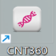, then turn on the instrument.
Important notes:
We strongly recommend that the control tissue and sample tissue be placed on the same slide when using the instrument. In case of user error (such as accidentally pasting the wrong slide ID label on the slide or forgetting to use a liquid cover) or an instrument failure, this method will greatly reduce the risk of missing poorly stained slides.
- When staining cryosections, please use the operating protocols that do not include hydrogen peroxide. Hydrogen peroxide can cause foam, which affects staining.
- The system should not be left unattended for a long time, so we recommend:
- For each instrument, perform a power cycle every 24 hours (turn off, wait 30 seconds, then turn back on). This allows for cleaning and filling of the fluid loop system.
- The software should be closed every day. This clears the software cached data to make the software more suitable for long-term operation and maintain system performance.
- After continuously running two batches of slides on the same slide tray, the "mixing station unavailable" notification icon may appear. This is the standard operation, indicating that the mixing station is being cleaned. Wait until the cleaning is complete, and then place another batch of slides on the slide tray.

3. Hardware

3.1 General description
This chapter is aims to inform you about:
- Names of each component
- What do these components do and how do they relate to the overall system?
- Where to find more detailed information, such as operation and maintenance procedures related to the component.

3.2 System components
The system consists of the following main components:
- Processing module, in which to fix the tissue sample slides and perform the staining operation. refer to 3.3 " processing module ".
- A host computer with a keyboard, mouse and monitor, is used to run the client software to control the processing module.
- A slide label printer, which to print labels for the system to identify slides.
- To print reports, you may also need a standard printer with a USB connection.
It also includes the following auxiliary devices:
- Large reagent containers (see 3.3.8)
- liquid cover (see 3.6.2)
- Slide tray (see 3.6.3)
- Reagent tray (see 3.6.4)

3.3 Processing module
The processing module is the staining operation platform of the system, and each processing module must be initialized before it can be used. This is specified in 3.3.1 "Initialization of the processing module".
Figure 3.1 and Figure 3.1 & 3.3 show the main components of the processing module, the numbered components are:
No. | Name | Chapter | No. | Name | Chapter
1 | Instrument cover | 3.3.2 | 8 | Washing area and mixing station | 3.3.10
2 | Robotic arm | 3.3.3 | 9 | Aspirating probe | 3.3.9
3 | Scanning module | 3.3.3 | 10 | Reagent platform | 3.6.5
4 | Front panel | 3.3.7 | 11 | Power switch | 3.3.11
5 | Large container cabinet | 3.3.8 | 12 | Control panel | 3.3.12
6 | Liquid car | 3.3.6 | 13 | Cooling module | 3.3.13
7 | Slide staining unit | 3.3.4 | 14 | Heating module | 3.3.14

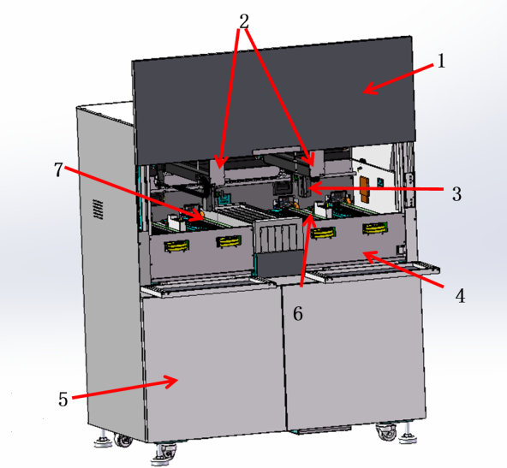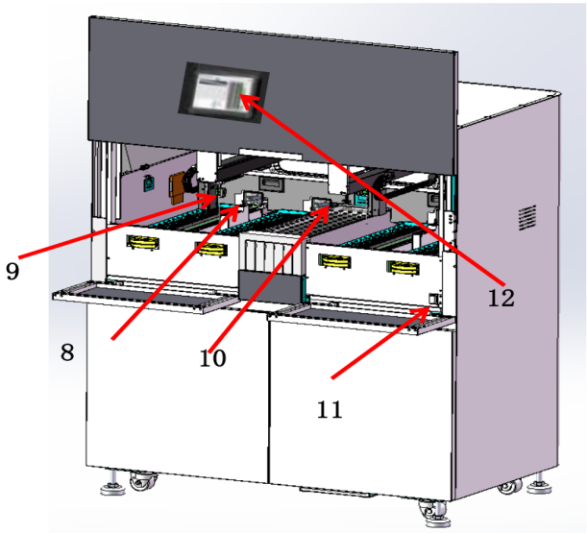
Figure 3.1: Left view of the processing module Figure 3.2 Right view of processing module

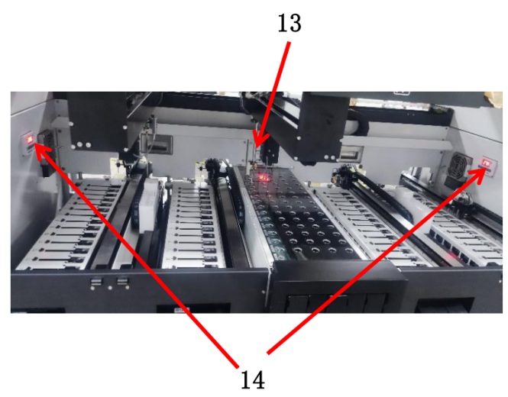
Figure 3.3 Heating & cooling module indicator

3.3.1 Initialization of the processing module
When powering on the processing module, the system starts to perform an internal detection, fills the liquid system with liquid and resets the robotic arms to home positions. In addition, the slide staining unit will also start and return to the unlocked position. If an error is found or the processing module is not suitable for operation, the initialization process will stop. Before attempting to start the processing module, check the following items:
- Make sure the aspirating probe is raised.
- Make sure the instrument cover and front doors are closed.
- Make sure the large waste containers are less than half full.
- Make sure that the large reagent bottles are more than half full,
- Make sure the mixing stations are in correct position.
- Make sure the bottles in the mixing station are empty and clean.
Note: always make sure that the aspirating probe is raised before turning on the processing module. If the aspirating probe is lowered when the processing module is powered on, the robotic arm may move before the probe is raised, which may damage the probe.
When the initialization process is finished, the status light indicator in the front of the processing module will turn green and the software will show that the instrument is connected. Do not try to use the processing module until it is fully initialized.

Instrument cover
The instrument cover must be closed during operation and protected with interlocks.
Warning:
- The processing module has an interlocks protection, which can stop operation when the instrument cover is opened. Do not try to open the instrument cover during operation and do not try to by-pass the interlocks.
- During operation, the processing module uses a aspirating probe whose position is determined by an automatically controlled moving metal robotic arm. There is no early warning for movement of the robotic arm and aspirating probe, and the speed of movement can cause injury.

3.3.3 Robotic arm and Scanning module
The Robotic arm controls the position of the aspirating probe to aspirate and dispense reagents. The robotic arm holds the scanning module, as shown in Figure 3.4, which is used to identify slides and reagents loaded into the processing module.
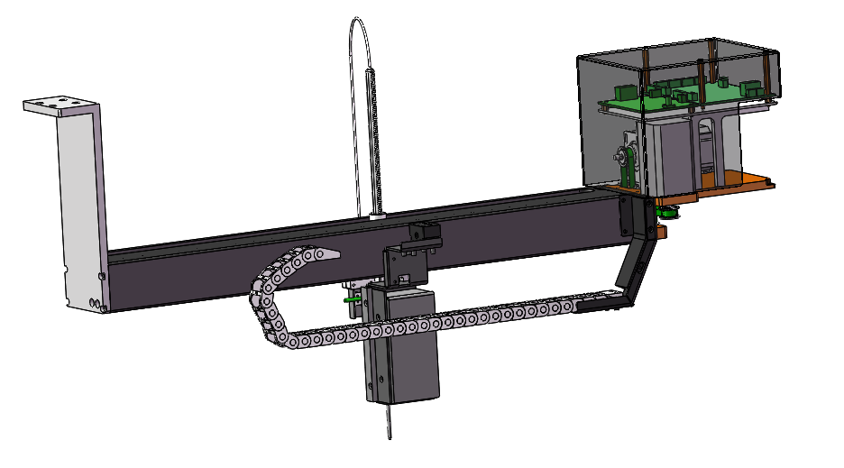
Figure 3.4: Robotic arm, the arrow indicates the scanning module
For slide identification, the system captures an image of each label, and then runs a recognition program to identify individual slide (scanning modules can recognize 1D and 2D codes).
Each processing module has two robotic arms. The left robotic arm (call it as 1#ARM for short) is charge of the CM1 and CM2 staining operation, the right robotic arm (call it as 2#ARM for short) is charge of the CM3 and CM4 staining operation (CM is for short of “slide staining unit” or core module in the software).
Note:
- The scanning window of the scanning module must be cleaned regularly.
- If the aspirating probe is broken or bent, replace it as described in chapter 12.3.2 "Replacement".

3.3.4 slide staining unit
Slide processing is performed in slide staining units. Each processing module consists four slide staining units (somewhere use “CM” or “CoreModule” for short）
Warning: The temperature of slide staining units may be very high, which may cause serious burns. Do not touch the slide staining units or their surrounding area within 10 minutes after the processing module stops working.
Warning: During the system operation, some reagents (including potentially hazardous reagents) may accumulate around the slide staining units. During slides insertion and removal from the slide tray, the accumulated reagent may contaminate the slide tray, which may contaminate the preparation plate (if used). Although the risk of adverse effects to the surrounding environment and users is minimal, users should still wear suitable protective clothing and gloves for slide tray operation and preparation plate operation.
To start the process, insert the slide tray into the slide staining unit through the front panel and then press the load button on the software status screen. The system will start to identify the slide labels. If the slides are compatible and all reagents are in place, the operator can start the experiment. During operation, the system locks the slide tray to the slide staining units. When the system is in the process of operation, do not try to pull out the slide tray. If need to pull out, please abandon the experiment or after the experiment is done,then press unload button to unlock the slide tray, wait for the system to unlock the slide staining units.
The maintenance components of slide staining units are liquid covers and liquid cover fixing clamp, which can help to fix slide and liquid cover in the slide staining units. For cleaning and routine maintenance of slide staining units, please refer to 12.4 "slide staining units".

3.3.5 Slide heater
The instrument has a heating element at the position of each slide. Each heating element is independently controlled and marked as an error when there is a temperature error (see Figure 3.5). In case of heater failure, please contact technical support.

Figure 3.5: single heater error
Do not attempt to operate the slide that needs to be heated at the position marked as error. If a heater fails during operation, the slide at that position will not be processed correctly. If the heater failure will cause potential risk, the processing module will turn off all slide heaters, including the other heaters which slides needs temperature control.

Figure 3.6: the gray heater symbol for each position indicates that the heater is completely off
Once the slide heating is turned off, you must power off then restart processing module to unlock the heater. Remember not to use the corresponding slide position with error before the heater is repaired.
If the slide does not require heating, you can continue to use the slide position with the error heater.
The maximum temperature of the heating plate is 101 ℃.

Liquid car
The instrument has four liquid car devices for adding large reagents. They move along guide rails in each slide staining unit to add reagents to the designated slides. It is only used to add large reagents in the 150 µl position and is not used in other positions. Each slide staining unit is equipped with an independent cleaning tank and they work independently of each other.
During the moving of the liquid car, the slide staining unit must be in the locked state. If the slide staining unit is not in the locked state, the liquid car moves and an error will be reported. Avoid the tube bumps during hand drag.
When it is necessary to lift the slide staining unit, first confirm if the liquid car is in the initialization position, that is, the reset position. If the liquid car is in the upper position of the slide staining tray, the tray will be pressed by the liquid car and cannot be lifted during the lifting process, resulting in an error.
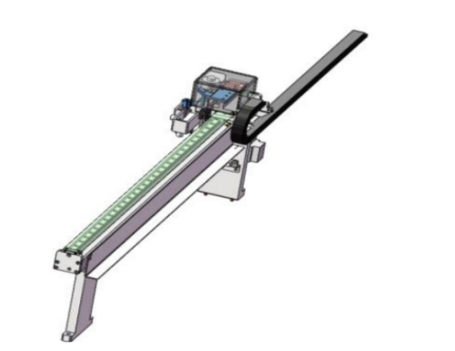
- Figure 3.7: liquid car

3.3.7 Front panel
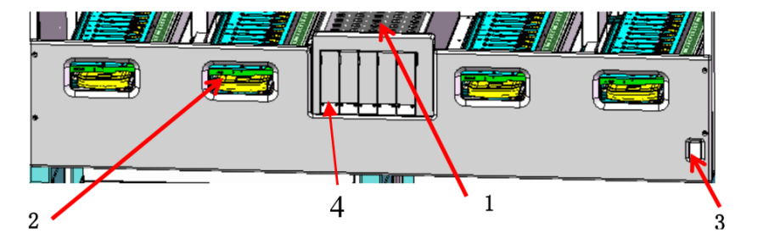
Figure 3.8: front panel
4
1
3
2
No. | Item | No. | Item
1 | Reagent platform | 3 | Power switch
2 | Slide staining unit | 4 | Reagent tray bracket
Slide staining unit
- There are four openings (one for each slide staining unit) to insert trays of 15 slides each (60 slides at a time).
- When the slide stay is fully inserted, press button in the software to lock the slide tray into the slide staining unit.
- After the slide tray is locked, the robotic arm moves the scanning module over the slides in the tray, automatically identify the slides.
Reagent platform
- This platform is where the reagent trays are placed, which are used to hold the 7 ml and 30 ml containers or the detect system reagents.
- Each reagent tray can hold up to 14 reagent containers and the reagent platform can hold up to 5 reagent trays (70 reagent containers).
- To load a reagent tray, press out button or in button on the software status screen. After click out button, wait the reagent tray bracket sliding out completely, then hold the reagent tray with prepared reagent containers onto the bracket, then press in button the load the bracket into the platform. When the robotic arm is ready, the system will identify the reagents in each position of the reagent containers. If need, you can control the reagent trays move in or out at any time, as long as it does not contain a reagent that needs to be used later in the process.

3.3.8 Large container cabinet
The large reagent containers, waste containers and the air conditioning condensate container are placed into this rack. Once placed int the corresponding position, close both doors, the doors are controlled by magnetic locks. To open the door, gently pull on the top of each. If the door is opened, the software will display a warning.
Note: During the slide staining process, the large container cabinet doors should keep closed.
Facing the processing module, the following containers have fixed positions, in the order from left to right:
Container | Volume（L） | Color | Remarks
Air conditioning water | 4 | Brown | To cooling module
Hazardous Waste | 4 | Brown | high-concentration waste
ER1 | 4 | Purple | Epitope retrieval solution1*
ER2 | 4 | Purple | Epitope retrieval solution2*
Dewax | 4 | Dark Red | Dewax Solution*
DI water | 4 | Blue | Deionized water
Wash buffer | 4 | Green | Washing Solution*
Alcohol | 4 | Orange | 100% Ethanol
Standard waste | 4 | Gray | low-concentration waste
Standard waste | 4 | Gray | low-concentration waste
⁎Use only Celnovte reagents, do not substitute with alternative products
The large reagent container is equipped with a liquid level sensor, which will give a warning when the reagent liquid level is low; the waste container is also equipped with a liquid level sensor to respond when the liquid level is too high.
Note：
- If the waste liquid level warning is activated during the staining operation, the operation will be aborted to prevent reagent spillage.
- Make sure the large container is in the correct state every morning: empty the waste liquid containers and fill the large reagent containers. Before using the processing module, make sure that the large container is in the correct position. If a container is missing, the processing module will stop.
- Before starting the processing module, make sure that the waste containers are less than half full and the container covers are firmly closed. If the cover of the container is not properly closed, in case of the failure of the liquid level sensor, the waste liquid may overflow or splash out of the container.
The waste liquid produced by DAB or other chromogenic reagents should be sent into the hazardous waste container and the other waste liquids should be sent into the standard waste container.

3.3.9 Aspirating probe
The aspirating probe aspirates the reagent from the containers, delivers the reagents to each slide in the slide staining units, and mixes DAB or other chromogens in the mixing station. The probe is equipped with a liquid level sensor to detect reagent level. Each container has a residual capacity that the probe cannot reach, called "dead capacity". The invalid capacity of each type of container is different. The method of replacing the aspirating probe is described in 12.3.2 chapter.

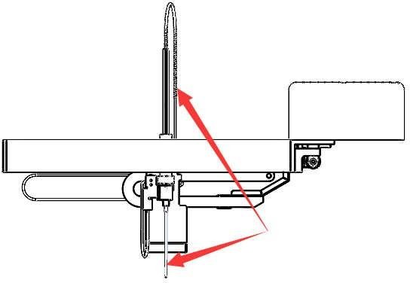
Figure 3.9: schematic diagram of the aspirating probe (arrow)mounted on the robotic arm

3.3.10 Washing area and mixing station
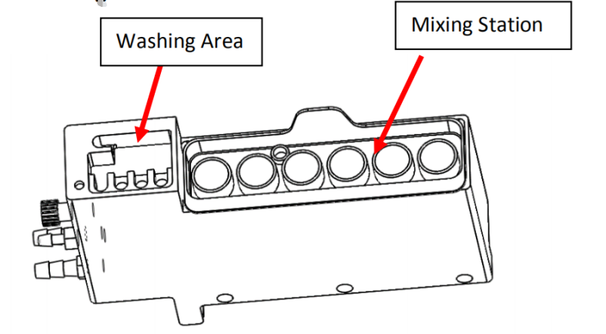
Figure 3.10: Schematic diagram of the washing area and mixing station
As shown in Figure 3.10, the small holes in the washing area are used for aspirating probe washing. The mixing station consists of 6 round holes. Standard mixing vials are inserted into these round holes to hold reagents that need to be mixed just before use. This is determined by the software and reagent type, and operates automatically when needed.
Note：
- Before starting the experiment, suggest you check the mixing vials, empty the mixing vials.
- The mixing station must be in position before starting the processing module each initialize.

3.3.11 Power switch
Power switch indicator:
- Light is on: the processing module is on.
- Light is off: the processing module is off.

3.3.12 Control panel
The control panel is a touch screen tablet, which allows the daily operations of the processing module to be carried out, it is also removable, allowing the equipment to be controlled remotely under the WIFI connection range.
when you need use the control panel to monitor the staining procedure, please connect the control panel and the host computer with the mini router.

3.3.13 Cooling module
User can turn on the switch of the cooling module according to their needs, and the reagent area can be kept at 15-18 ℃. As shown below.
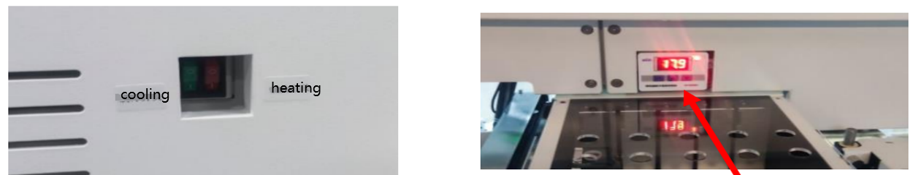
Figure 3.11 Cooling and heating module switch & Cooling module temperature display interface

3.3.14 Heating module
Users can turn on the switch on the heating module to maintain the ambient temperature of the slide staining units between 25 and 30 ℃. As shown below.
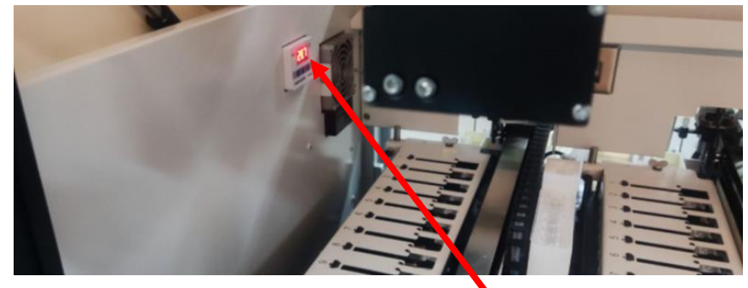
Figure 3.12 Heating module temperature display interface

3.4 Host computer
The host computer as a control system controls the processing module and provides data storage. If the slide label printer and standard printer need to be installed, the main computer also provides the connection of these devices. During the system installation, the host computer will be configured and connected to the processing module.
Note: Do not power off the computer during operation. To change the users who are logged on to the computer, click “logout” from the “Start” menu of the operating system instead of restarting the computer.
The following ports may be used by the system:
- USB interfaces: used to connect standard printer or slide label printer
- Parallel port: used for slide label printer
- Network connection port: connect to the processing module by a hub or a router, or directly connect to the processing module.
- WIFI connection: Connect with the mini router when need to use the control panel to monitor the staining procedure.
Notice: To avoid any possibility of delays or interference with system control, please do not install any additional software on this computer.

3.5 Slide label printer
The system provides a unique slide identifier for each slide. The slide label printer is used to print these unique identifier labels which are then affixed to slides. When the slides are loaded into the processing module, the software will obtain the images of the slide labels to determine the position of each slide.
The slide label printer is connected to the computer through the parallel port or a USB port, installed and tested when the system is installed. For the information about labels, label tape replacement and cleaning, please refer to the documentation provided with the label printer.

3.6 Auxiliary devices
This chapter describes the auxiliary devices that must be used with the system.

3.6.1 Slides
The following figures show the areas of the slides that can be used. The dispense capacity refers to the setting you can choose when setting up slides with the software.
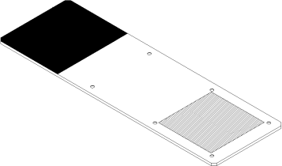
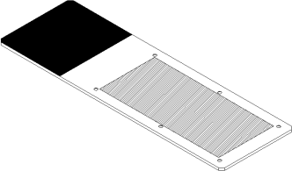
Figure 3.13：100μL or 120 μL Figure 3.14：150μL
Slide specifications:
Size | Width： | 24.64 - 26.0 mm (0.97-1.02 in)
Size | Length: | 74.9 - 76.0 mm (2.95-2.99 in)
Size | Thickness： | 0.8 - 1.3 mm (0.03-0.05 in)
Label area | Width: | 24.64 - 26.0 mm (0.97-1.02 in)
Label area | Length: | 16.9 - 21.0 mm (0.67-0.83 in)
Material | Glass | ISO 8037/1

Note: Do not use slides with missing corners. These slides may fall from the slide tray and cause the processing module to abandon the batch of slides.

3.6.2 Liquid cover
The liquid cover is designed for optimal staining and is a necessary part of the staining system. After placing the slide on the slide tray, you must cover the slide with the liquid cover. The pin on the liquid cover must be properly positioned into the slot in the slide tray.
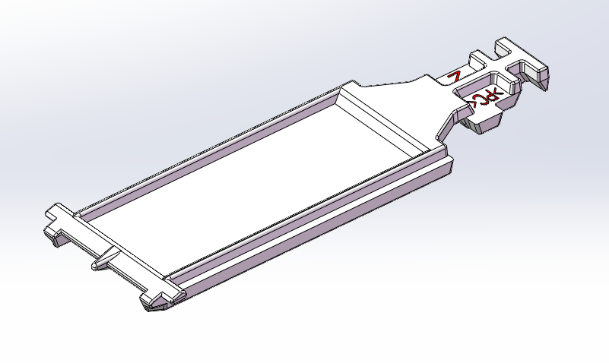
Figure 3.15: liquid cover (arrow shows liquid cover pin)
As long as the liquid cover is not heavily discolored or damaged and the cleaning method is correct, it can be reused up to 25 times. Discard the damaged or discolored liquid cover. Refer to "12.6 liquid cover" for details of cleaning and reuse liquid cover.

3.6.3 Slide tray

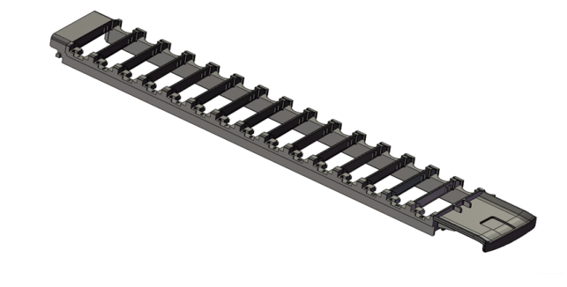
Figure 3.16: slide tray
When the slides are loaded into the processing module, the slides and liquid covers should be fixed on the slide trays. Each slide tray can hold 15 slides.

3.6.4 Reagent tray

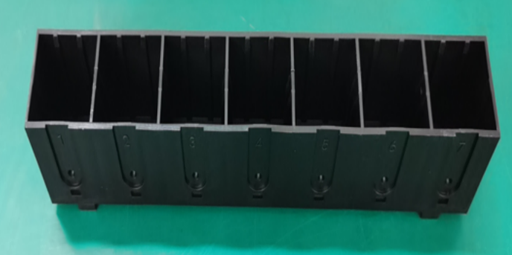
Figure 3.17: reagent tray
- The reagent tray can be installed with 7ml and 30ml reagent containers, and the reagent tray can be placed on the reagent platform. There are seven installation positions for each reagent tray.
- There is a slot in each cell of the reagent tray to ensure that the reagent container is placed in the reagent tray in a correct direction. This is very important because the identification tag on the top of the container must be in the specified position, so that the scanning module on the robotic arm can successfully obtain the its identification image.

3.6.5 Detection system, reagents and open containers

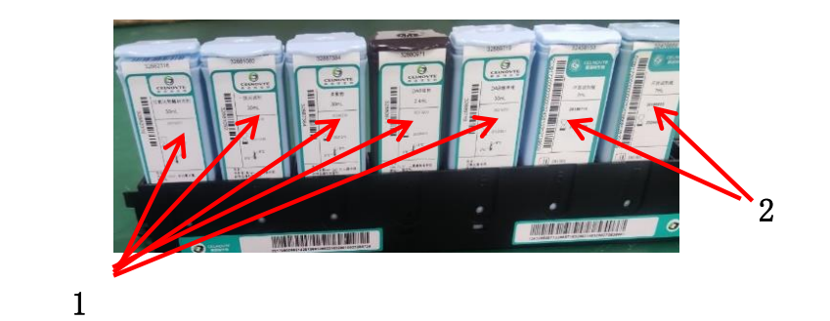
Figure 3.18: 1. Detection system, 2. Open container
Detection system
As shown in Figure 3.18, a group of predefined reagents on the reagent tray corresponds to the detection system (1). The predefined reagents are provided in concentrations optimized for the system, so require only registration and opening before use. On the reagent tray there are seven spaces available for other reagents, such as using open containers for the primary antibodies (2).
If the detection system is depleted or expired, discard the entire set of containers.
Large reagents
For the filling and disposal of the large reagent container, see "3.3.8 Large container cabinet".
Titration reagents
For primary antibodies and detection system components, a suitable 7 mL or 30 mL container is used for the reagent tray. There are also special purpose titration vessels, including a removable tube for the titration reagent use. Titration containers are available from the vendors as ancillary supplies for reagent optimization.
Open container
As shown in figure 3.18, a clean, empty containers are used to hold a user-supplied reagent (such as a primary antibody). Open containers can be used with one reagent only, and the same reagent can be added up to a certain number of times.
To use the detection system and reagents, you must:
- Register reagents
- Place all containers in the reagent tray
- Open all container covers and attach them to the retaining clamps on the back of the container.
- Load the trays onto the reagent platform

3.7 Large container
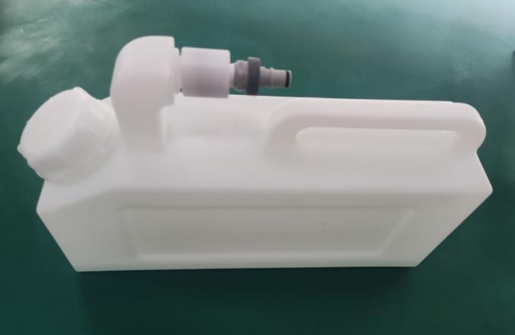
Figure 3.19. Large container
There are six 4-liter large reagent containers, two 4-liter low-concentration (standard) waste containers, one 4-liter high-concentration (hazardous) waste container and one 4-liter air conditioning condensate container, which are standard parts of the system and are installed by your service representative.
Note: Before starting the processing module, ensure that the container cover is fixed. If the container cover is not fixed properly, in case of the liquid level sensor failure, the liquid may overflow or eject from the container.
A liquid level sensor on each large reagent and waste container alert the user when the reagent level is low or the waste lever is too high.
Note: Use proper handling when emptying the waste container.
Certain reagents used in immunohistochemistry and in situ hybridization are hazardous. Please make sure that you have received adequate training on these operation before proceeding.
1) Wear protective gloves, eye protection and appropriate protective clothing before touching reagents or cleaning instruments.
2) All relevant laboratory procedures and government regulations must be followed when using and handling reagents and concentrates.

4. Software

4.1 General description
The software of the automatic immunohistochemistry staining system adopts the standard Windows operating principle and method. To make it easy to run and use the system software, you should be familiar with the operation and use of mouse and standard windows.
 Note:
- Since the software is responsible for controlling important hardware and storing key data, do not run other applications that occupy virtual memory on the computer that controls the processing module. If other applications occupy too much virtual memory, the software may shut down and display alarm error at the same time. If this happens, restart the software.
- Do not power off the computer while it is running. To change the user who is logged on to your computer, use “logout” from the “Start” menu instead of shutting down your computer.
- The software, like most Windows applications, uses the system settings to print the date and time on the report. In some cases, too long date and time formats can exceed the available space for dates. To ensure that your information will not be lost, set the short date format to a maximum of 12 characters and the long date format to a maximum of 28 characters.
This chapter aims to inform you about:
- Software startup
- Notifications, warnings and alerts
- System basic settings

4.2 Software startup
After starting the windows operating system, double-click the software icon to start the software. The icon is placed on the desktop of the computer operating system during installation. During system startup, the “Status” screen is displayed.
After the software completes the startup process, the main screen will be displayed. At the top left of the screen are some common features of all the software pages. These functions are described in the following sections and the general functions of the software are described.
There are three account usage types with our software( V15 or above version) .
- without login, only to monitor the running status
After you open the software, default it enters this type user status. Without login, you cannot edit or modify the information.
- Admin account.
Click “Login” on the right top corner to use “Admin” user and “123” default password to login. Suggest you modify the password after first login. (Click “Admin” on the right top corner, then click “Password” to open the modification password window) Please remember the password.
Or please contact the service person use the “Service” account to create other users.
With this account, the below functions will be opened.
- To add a new protocol, or copy a predefined protocol to generate yourself protocol under Protocol screen.
- To set the BarcodeTemplate under Maintenance screen.
- To perform the maintenance tasks under Maintenance screen.

4.3 Notification, warnings and alarms
The system has three alert levels with audible and visual signals: notifications, warnings and alerts. Each alert is indicated by an icon on the “status screen”, which is located on or next to the item in the alert message. The corresponding alert icon may also be displayed on the processing module tab of the instrument list to provide instructions that are not limited by the current visible screen.
Right click the alert icon and select “attention information” to launch a dialog box that describes the alert in detail.
Note: Not all notifications or messages appear on the processing module tab, but on the “status” screen of the software. Check the status screen to make sure that no information is ignored and take action accordingly.
The three warning levels and their related icons are described as follows:

Note:
- Before a protocol begins operation, a component is in an unexpected state, which must be attended to.
Stable
- During operation, a component is in an unexpected state, but the current batch of slides will continue. No action is required.

Warning:
Stable
Warnings are used when all of the following conditions occur:
    - A component is in an unexpected state;
    - the current slide may be affected;
    - User operation is necessary (and possible) to avoid negative effect of the current slide.

Warning is also used when any of the following conditions occur:
- Measures must be taken to avoid damaging the instrument or compromise safety;
- There is an error that causes the instrument not to complete its initialization
Alarm:
- Alerts are used when all of the following conditions occur:
Flash
- A component is in an unexpected state;
- The current slide may be affected;
- Immediate user action is required (and possible) to avoid negative effects on the current slide.
- Alerts may also be used when immediate action is required to avoid damage to the instrument or compromise safety.

4.4 basic settings for Windows OS system
This section contains the basic setup options available for the Windows OS system. Please follow the "Create a new login account" steps to add a new account or you can contact your IT department to create a new login account to access the Windows OS desktop.
4.4.1 Create a new login account
The laboratory administrators can create a new user and senior user login accounts, so that employees can enter the system as their own identities (instead of using a single default login).
Use the following steps to create a new account:
1. Make sure there are no batch slides in process or waiting to be processed, and then close the software.
2. Make sure the lab administrator (with senior user access level) has currently logged in to the host. Log out if necessary, and then log in as an administrator.
3. Choose the “Control panel” option from the windows “Start” men
4. Click the “Management tools” icon from the “Control panel” window.
5. Double click the “Computer management” icon from the “Administrative tools” window.
6. Double-click the “Local users and groups” item from the “Computer management” window.
7. Right click the “Users” folder and select the “New user” option from the shortcut menu.
8. Complete the following items and options in the “New user” window:
- Enter the new user login name in the "User name (U):" column
- Enter the user’s full name in the "full name (F):" column (optional)
- Enter the description of the new user in the "Description (D):" column (optional)
- Enter the user password (case sensitive) in the "password (P):" column
- Enter the password again in the "Confirm password (C):" column to confirm (case sensitive)
- Set the “Password never expires” option
- There is no need to check other options
9. After filling in all the contents, click create.
10. After adding all other users, enter new information about other users and click close.
11.This procedure has created a new user (or multiple users) with a user access level.
1） If the user level is enough to guarantee the access of the new account, close the "Computer management" and "Administrative tools" windows to end the operation process. The new account will be available at login time.
2）Continue to grant an account the administrator (senior user) access level according to the remaining instructions.
12. From the list of accounts (the right pane of the "Computer management" dialog box), double-click the account with administrator (senior user) access level you want to have.
13. In the “Account attributes” window, select the “Subordinate” tab.
14.The “Subordinate” list shows the account level group to which the current account belongs. New account members, if they need higher level access, must add other groups.
15.If you want to add “Senior user” access to your current account, click add….
16.From the “Select group” window, click Senior.
17.Click “Find now” from the extended “Select group” window to list the access level groups registered in the system.
Note:
Although a series of access level groups are available, only "Users" and "Senior users" can operate. Operations of other groups are invalid (so the account only exists as a user), or cannot be set (such as administrator).
18.Select the “senior users” group and click OK.
19.In the retracted “Select group” window, click OK to confirm the access level settings.
20.The account properties window shows that the account is a member of the “Senior users” group.
21.Click OK to end the account setup for this account.
22.Repeat steps 12 to 21 to change the access level of other accounts.
23.When all accounts are set up, close the “Computer management” and “Administrative tools” windows.
24.The new account will be available at login time.

5. Status screen
In the clinical client, each processing module has two status screens. After selecting someone processing module in the left instrument list tab, you can choose to display the “Status screen” or “Program status” screen by scrolling the mouse wheel on the status screen. "Status screen" provides system control by displaying the view of slide and reagent position in the processing module; the “Program status” screen displays the protocol progress information of individual slides.

5.1 System status screen
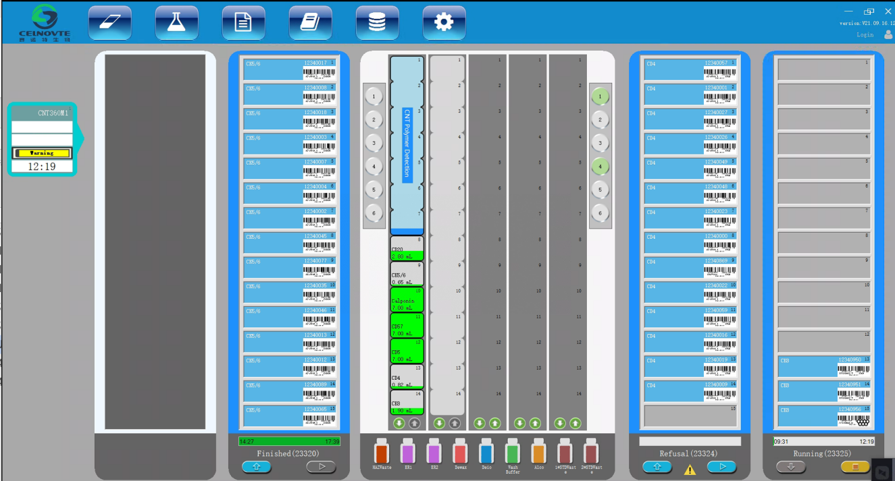Figure 5.1 Status screen
The screen allows you to control the operation and can display the details of loaded slide trays and reagent trays, as well as the status of reagents, waste and system safety alarms.

5.1.1 Hardware status
If a component of the system fails, a “warning” icon will appear on the screen in the corresponding position with abnormal notice information, there will also be corresponding warning notices when other experimental conditions are not met.

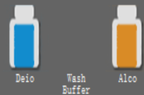 | Large reagent (wash solution) is not present,  large reagents (DI water,100%ethanol) are present.
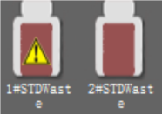 | 1# standard waste container is full.
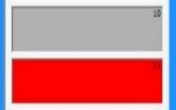 | 10# heating plate exists and is normal.  11# heating plate does not exist.
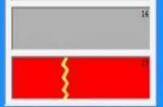 | 14# heating plate exists and is normal.  15# heating plate exists but is damaged.
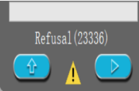 | the experimental conditions are not met, usually due to the lack of large reagents or open reagents.
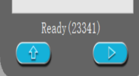 | Slides are ready and experimental conditions are met.
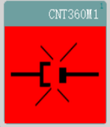 | The instrument is disconnected from the computer.
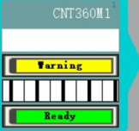 | Slide tray unit status indicator:  #1 is not locked, #2 warning, #3 scanning the slides #4 is ready.
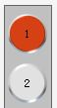 | Mixing station:  #1 has reagents, #2 has no reagents
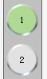 | Mixing station:  #1 is cleaning, #2 has no reagents.
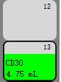 | Reagent tray:  There is no reagent container in #12 position,  The remaining volume of the #13 container is 4.75mL.
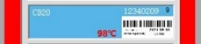 | Slide tray:  #9 heating plate, high temperature(red),98℃
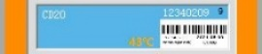 | Slide tray:  #9 heating plate, medium temperature(orange),43℃

When the slide tray unit rises above the room temperature, a temperature indicator appears in the frame of the slide display on the “status screen”. The temperature indicator bar on the slide viewing frame is blue when the unit is at room temperature, orange when warm, and red when hot.

Figure 5.2 temperature indicator bar
 Warning: The slide tray unit and its surroundings, as well as the slides in the slide tray, may be hot and can cause severe burns if touched. Do not touch the slide tray until the software prompts the temperature to drop. If the software is not running, wait at least twenty minutes after removing power from the processing module.

5.1.2 Protocol progress
During the execution of the protocol, the system will monitor the independent operation status of each slide tray unit, update the display of the steps that are being executed in real time and update the estimated completion time of the protocol.
As shown in Figure 5.3, it shows the estimated completion time of the protocol on slide tray unit #1, #2, #3, and #4, which will be updated and corrected as the protocol progresses.
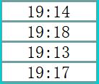
Figure 5.3 Estimated protocol completion time for each slide tray unit
The working status of the slide tray unit will also be displayed on the interface in the form of a progress bar, as shown in Figure 5.4, which makes viewing the protocol progress more intuitive.
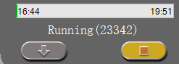
Figure 5.4 Running status of the slide tray unit
To cancel an experiment, click the Abandon button below the protocol progress bar, this will exit the protocol, as shown in Figure 5.5.
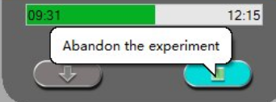
Figure 5.5 Abandon the current experiment

5.1.3 Delay start
Runs with waxed slides can be scheduled to start at a specified future time(such as the second day ). Runs started overnight, for example, can be timed so that they finish shortly before start of work on the following day.
Setting delayed start time
To run a tray with delayed start, prepare slides as usual and lock the slide tray. When the run status is Ready，right-click some one slide to select Delay start from the pop-up menu on the system status screen. Set the date and time that you want the tray to start in the delay start dialog, and click OK. The tray changes the Ready status to “Reserve”.
Note: Once setting the delay start, please do not change the status. Such as pull out and pull into the reagent trays.

5.2 Program status screen

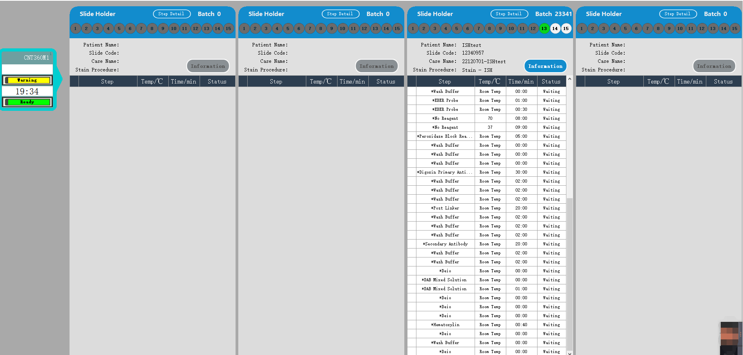
Figure 5.6 Program status screen
This screen allows you to view properties and performance information for each slide in each slide tray unit. When a slide position is selected, the software displays slide details and reagent step details, for real-time monitoring.

5.2.1 Display slide properties
In the "Program Status "screen, select a slide staining unit, click a slide numbered 1-15 above the slide holder interface, you can see the detail information of that slide as shown in Figure 5.7. The slide information displays the patient’s name, the slide code, the case name for the slide, and the staining procedure used for the slide. the radio button that is grayed out, corresponds to positions without slides and cannot be selected, such as positions from 1 to 12 in Figure 5.7.
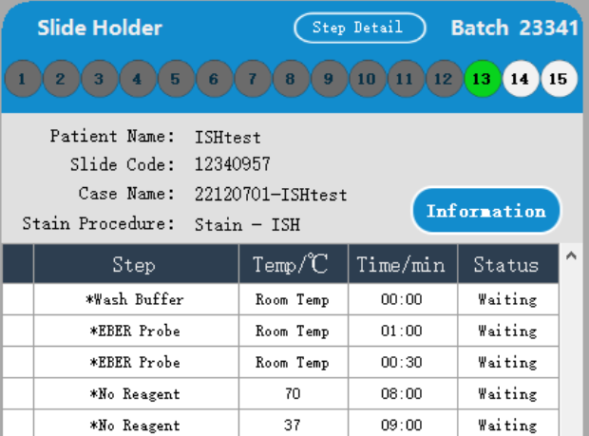
Figure 5.7 Slide properties screen
If the patient’s name is too long to fit in the available space (Slide tray unit 1, 2, 3 and 4), the end of the name will be truncated to " ... ", hover over the truncated name to see the patient's full name in a pop-up field.
To view additional slide details, click the "Information" button to open the Slide Properties dialog, as shown in Figure 5.8.
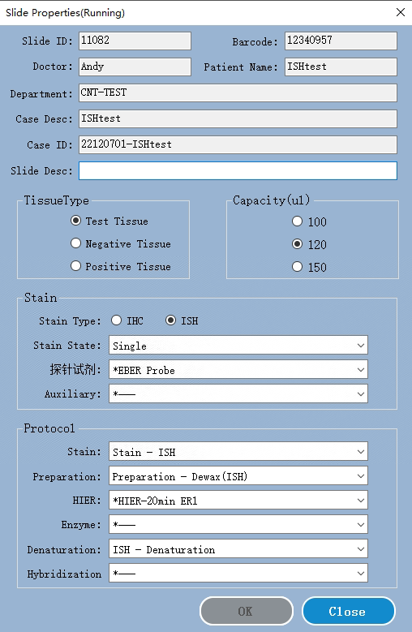
Figure 5.8 Slide properties dialog box

5.2.2 Display protocol execution steps
To view the progress of a slide run, click the corresponding slide position button near the top of the screen. The information of the reagent run steps of the selected slide is displayed and the temperature, interval time and status of each reagent run step will be displayed. For no slide positions, the radio button is grayed out and cannot be selected.
Figure 5.9 shows the progress of slide reagent steps at position 13 for a given slide tray unit. The status of a step marked with a green tick show "Execution complete", the status of a running step shows "Executing", and the status of a not executed step shows "Waiting".
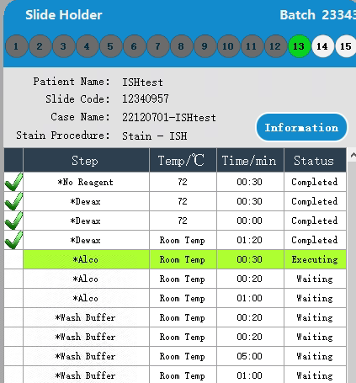
Figure 5.9. Example of execution status of a step

6. Slide management
Before using the processing module for staining protocols, cases and slides must be
added. The standard workflow includes the following.
The main steps:
1. Preparation of tissue sections on the slides.
2. Create a case for the slide in the system software.
3. Add or edit doctor details if needed.
4. Enter slide details.
5. Create control slides according to the laboratory's standard operating method.
6. Print and stick labels on the slides.
7. Place the slides and liquid covers in the slide tray and load it into the slide tray unit in the processing module.
Once slide processing begins, a number of slide reports and running cases can be generated on the Slide History screen.
If the standard workflows are not right for your lab, there are other workflows you can create to help you manage your daily workload.

6.1 Slide management screen
The slide management screen displays cases and slides that have been entered into the system but have not yet been processed. You can create cases and slides in this screen and edit them if necessary. The slide must belong to a case, so you have to create the case first and then the slide. To display the slide setting screen, click Slide settings Icon  .
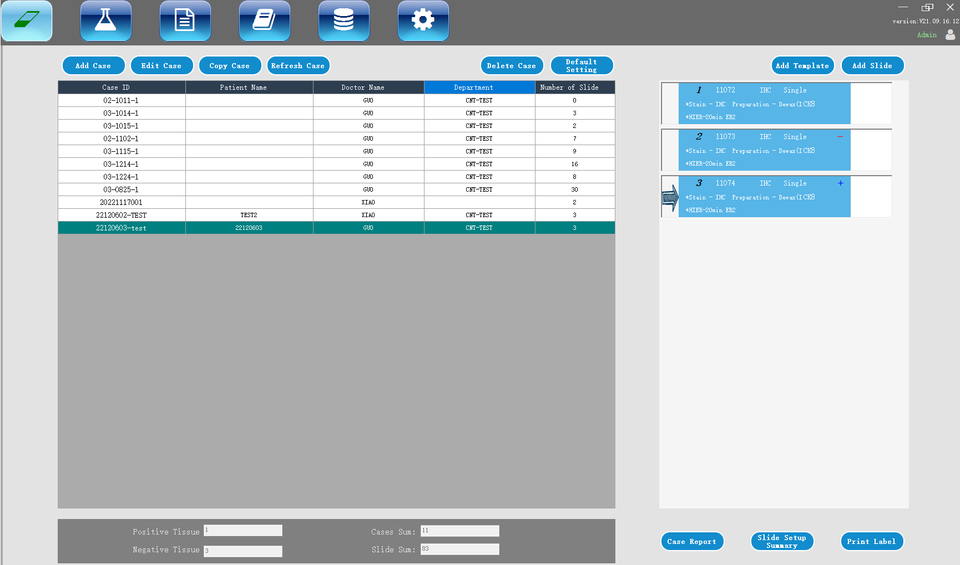
Figure 6.1 Slide management screen
Figure 6.1 shows the slide management interface. The left part of the screen contains cases operation and the lists for cases, and the right side contains slide operation and slides list of the selected case.

6.2 Use of control tissue
It is suggested that the control should be used as a routine item of the system. Some diagnostic systems include their own control slides, but the system specification may still recommend additional internal controls. Please remember: control is the inspection of the whole process. To test the performance of the system as completely as possible, it is strongly recommended that appropriate patient and control tissues be placed on the same slide. Although it is strongly recommended that the control and test tissues be placed on the same slide, the software also allows the slide to contain only the control and reagent controls. Be sure to carefully mark the slide with control tissue only to avoid mix-ups with the patient's test slides.

6.3 Case creation

This section describes the functions for setting up cases on the left side of slide setup screen. Detailed operations, such as to add, edit and delete, are given in following descriptive section.
The following chapters include:
6.3.1 Case controls and active case information
6.3.2 Case identification
6.3.3 Add a case
6.3.4 Case duplication
6.3.5 Edit a case
6.3.6 Copy a case
6.3.7 Case report

6.3.1 Case control and active case information

Click “Add case” to add the details of the new case. 6.3.3 “Add case” explains this process.
Click “Edit case” to edit the details of an existing case. 6.3.5 “Edit case” explains this process.
Click “Delete case” to delete the existing case. 6.3.6 “Delete case” explains how to delete case.
Click “Copy case” to add a case and its duplication. 6.3.7 “Copy case” explain how to copy case.
Right click the case and you can also find the “Edit”, “Delete” and “Copy” commands in the pop-up menu.
Click “Case report” (below the case list) to view the report of the selected case (see 6.3.8 case report).
The table below displays the following information for the active case:

Case ID | Case identification. It can be any alphanumeric character.  Since this field can contain letters and numbers, clicking on the Case ID column heading of the table sorts the field as text - identifiers starting with "10" will precede those starting with "2".
Patient name | Identification of patients
Doctor name | The name of the doctor or pathologist in charge of the patient.
Number of slides | The number of untreated slides set for the selected case. When the slide staining process is started, the slide is moved from the slide setting screen to the slide history screen, and the number is updated accordingly.

6.3.2 Case identification
The system uses two main case identifiers: Case ID and case number, those are “Case ID” and “Case number” respectively in the software).
- Case ID: The Case ID entered by the user using the laboratory identification method., the Case ID is entered in the “Add case” dialog box when the case is created.
- Case number: The system automatically assigns a unique identification number to each case. The case number is displayed in the case properties dialog box.

6.3.3 Add case
To add a case, start from the slide setup screen to perform the following:
1. On the slide setting screen, click “Add case” to display the add case dialog box (see Figure 6.2).
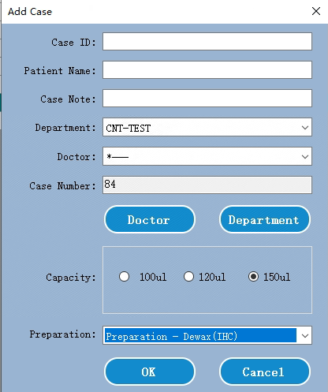
Figure 6.2 Add case dialog box
Enter the appropriate details in the fields Case ID, Patient name, Case Note, and Doctor.
2. If the required doctor is not in the doctor list, click “Doctor” to open the Doctor List dialog box to add the doctor (see 6.4 Doctor list).
3. If the dispense volume of the slide created for the case is different from the default dispense volume already set, select a dispense volume.
4. Select a preparation procedure option from the preparation protocol list to make it the default for case slides.
5. To enter the details of the case, click OK. To exit the dialog box without entering any information into the system, click Cancel.
6. The case is added to the case list.

6.3.4 Case duplication
The system does not allow new cases to use the same case ID as an existing case. Each new case must be given a unique case ID in the system, please do not use same case ID in the system.

6.3.5 Edit case
To edit the case details, select the case in the list, then double click or right click then select Edit to open “Edit the Case” dialog box, which is the same procedure as the Add case dialog box described above.
※If you edit the details of a case and the slide label of the case has been printed, you should reprint the label before trying to run the slide (a message will appear on the screen). And the system will not keep the history record of previous printed slides.

6.3.6 Delete case
To delete a case, select it in the list and click Delete.
- if a case contains in-process and processed slides, these slides also will be deleted.
- Deleting a case will also delete all the untreated slides created for the case.

6.3.7 Copy case
Copying a case is a very convenient way to create a new case for a patient. You can change the case details in the new case as needed, or keep the same. The new case number will be created automatically, but you must enter a new case ID.
When a case is copied, all processed and untreated slides belonging to that case are copied, ready for immediate label printing and staining on the slide setup screen. Unwanted slides can be removed by right clicking the slide and selecting Delete Slide.
Copy a case:
- Select the case to be copied from the case list on the left side of the slide setting screen.
- Click “Copy case” and the software will display the “Copy Case” dialog box.
- Change the Case ID and edit the case details as necessary, and then click OK.

6.3.8 Case report
You can generate reports for individual cases. The report can display the basic case details and the information of all slides in the case, such as slide ID and the staining protocols and reagents used for slides. There is a space on the printed report where you can fill in comments each slide.
Case report can be generated on slide management and history of slide screens. Select the appropriate case or slide and click the case report button. Only the case that its slides have been processed and unlocked in the processing module could be generated the report.

6.4 Doctor list
A list of doctors is saved in the system so that you can choose to add doctors to the case details. Select a doctor from the “Preference” Doctor List in the add case or case properties dialog box, or open the doctor list from the same case properties dialog box to add or edit a doctor.
For each doctor, the following fields are displayed:
- Name: doctor name
- Preference: preferred status of the doctor (when creating a case, only the preferred doctor will be displayed in the dropdown list). The status is set in the edit doctor dialog box.
Edit doctor dialog box has the following fields:
- ID: unique ID automatically generated and assigned by the system.
- Description: an editable field, for general comments or other name information.
Open the doctor list and click Add or Edit to add a new doctor or edit the details of an existing doctor. Editing is limited to comment fields and changing preferences. You cannot change the doctor's name after creating the doctor. Doctors can be removed from the Doctor List dialog box. Previously created cases containing deleted doctors will continue to display the doctor's name, but new cases will not be able to select the doctor.

6.5 Create slide
This section describes the slide creation and management in the slide setup screen.
6.5.1 Description of slide fields and controls
6.5.2 Create slide
6.5.3 Copy slide
6.5.4 Edit slide
6.5.5 Delete slide
6.5.6 Manually identify and remove slide
6.5.7 Add slide template
6.5.8 Dispense volume and tissue position on slide

6.5.1 Description of slide fields and controls
There are two buttons above the slide list:
- Click Add Slide to add a slide for the selected case.
- Click “Add template” to add a template for the selected case. Only after a reagent template which had bound with a default protocol, then you continue to operate.
Each slide displays the slide ID and the abbreviated name of the selected bookmark. The label area on the right side of the slide is coded with color to indicate the creation position of the slide. The details are as follows:
The slide shows the following symbols:
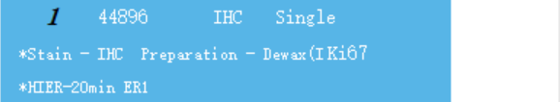 | White：  Slides created in the Add slide dialog box
The slide shows the following symbols:
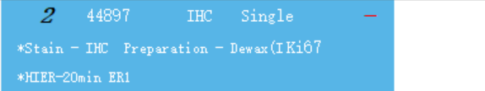 | Negative sign:  Negative tissue slide
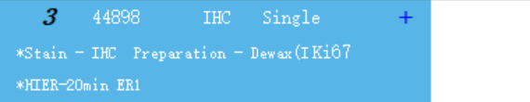 | Positive sign:  positive tissue slide
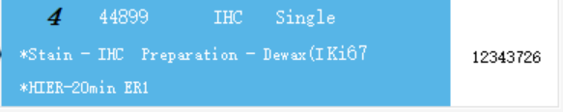 | Example tag:  Slide label is printed

Double click the slide to open the Slide Properties dialog box of the slide. Right click to delete the slide, print a label or to open the slide property.

6.5.2 Create slide
To create a new slide:
1. Click the case in the list of cases.
2. Click Add slide to open the Add slide dialog box. Here please set the Tissue type, the staining type, the staining protocol and preparation. If necessary, the slide dispense volume can be changed.
3. Click “Add Slide” to add the new slide into the slides list.
Continuously click “Add Slide” on the dialog box to add more slides with same details.
The new slide will be automatically numbered for a unique slide ID.

6.5.3 Copy slide
Copy an existing slide:
- Double click the existing slide to open the Slide Properties dialog box.
- Click “Copy” to duplicate a slide
The “Copy” button will be changed to “Add Slide” in the dialog box.
- Check slide details and make necessary changes.
- Click Add Slide to add more slides.
The new slide will be added to the same case that the duplicated slide belongs to.

6.5.4 Edit slide
To edit slide details on the slide setup screen, double-click the slide to open the Slide Properties dialog box. Change the details as described in 6.5.2. Then click OK to save it.
If you have edited the details of the slide with the printed label, you need to reprint the label before processing the slide. And the system will not keep the previous printed label information.

6.5.5 Delete slides
To delete a slide from the slide list, right-click the slide in the slide list on the slide setup screen, and then select Delete slide from the submenu. Then click “Yes” to delete it.

6.5.6 Manual identify and remove slides
Any slide in the system can be manually added and identified at any time. After the slide tray unit is locked and the system has scanned the slides, select the unrecognized slide or an empty position which you actually have put a slide, right-click "manually select", and the following window will pop up:
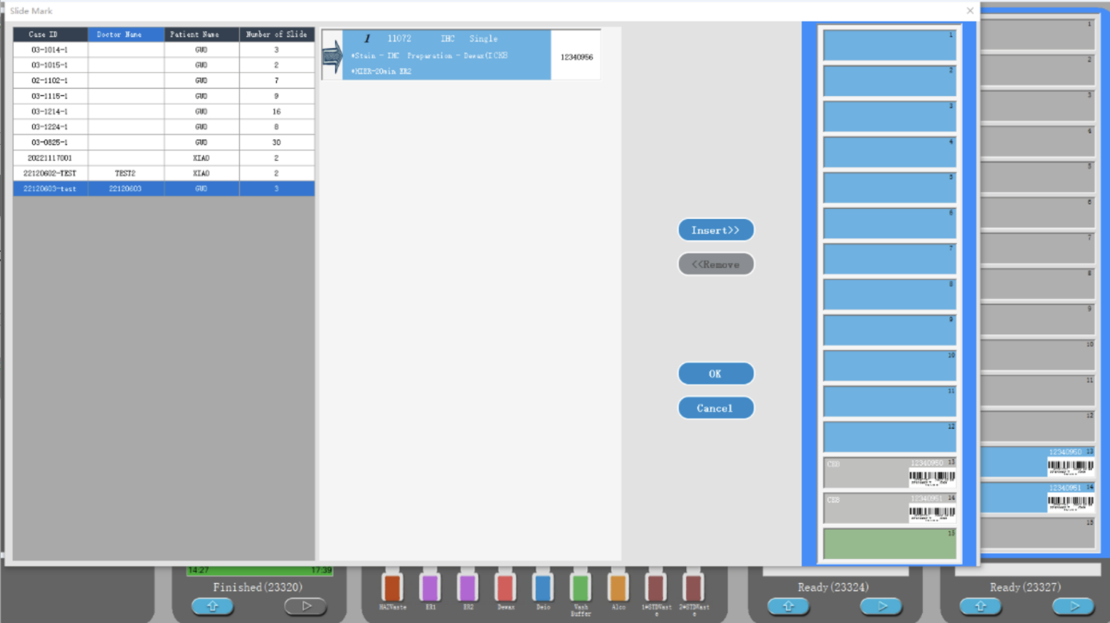
Figure 40: Manual ID input dialog box

Open the case and slide dialog box:
- Select the corresponding case, find the slide to be added, select the slide position to be inserted, click the "Insert" button, and then click the "OK" button.
- Find the slide you want to delete, select the position of the slide you want to delete, click the "Remove" button, and then click “OK” button.

6.5.7 Add slide template
Slide templates are predefined marker configurations for relevant tissue types. Templates allow you to quickly add multiple markers slides that are normally used together. To add a slide template to a case, do the following on the slide setup screen:
1. Click “Add template” to add a template for the selected case. Only after a reagent template which had bound a default protocol, then you continue to operate.
2. Select a reagent template from the drop down list and the slide will be displayed on the slide list.

6.5.8 Dispense volume and tissue position on the slide
The software has three capacity allocation settings, which are used to set each slide in the Add slide dialog box.
The dispense volume settings will determine the area where the reagent is distributed on the slide and how much reagent is dispensed.
- When a volume of 100 μL is dispensed, the Liquid cover is pulled down approximately halfway down the slide and the aspiration probe delivers the antibody to the top of the Liquid cover (approximately halfway down the slide).
- 120 μL volume is dispensed, the Liquid cover covers most of the slide and the reagent is still dispensed after it is pulled back to a proper position, allowing a larger area of the slide to access the reagent.
- For 150 μL dispenses capacity, liquid cover covers most of the slides, and is pulled back to a proper position, then the reagent is still transported on the top of the position, so that a larger area of slides can contact the reagent.

Differences in the area of the slides that come into contact with the reagents mean that proper tissue placement is important. For a 100µl dispensed volume, usually only one sample can be stained, and the sample should be placed in the lower half of the slide (away from the label). whereas, when you dispense 120 μL or 150 μL, it is easier to place two tissue samples on the slide; if there is only one sample, it should be placed in the middle of the slide.

6.6 Slide labels
All slides that need to be stained in the system must be labeled for software identification to run the correct staining procedure. All slide labels created in the software have label IDs (expressed in alphanumeric characters or bar codes) to automatically identify slides in the processing module. However, the slide label should also contain additional information that can be read manually so that the slide can be identified when the label ID cannot be automatically identified (for example, when the label is dirty).
Slides must be labeled before being placed on the instrument. It should be noted that the label is pasted correctly so that the scanning module can effectively scan the label ID (for barcodes or alphanumeric IDs).
You must use the slide label provided by the system to work with the slide label printer.
Printing labels and attach them to slides
To print a label for a single slide, right-click the slide and select Print label. In this case, the Print slide label dialog box does not pop up. On the system with a defined printer set, the default slide label printer will be used to print the label.
Please use the below steps to print more labels at one time.
- After setting all slides, click “Print label” on the slide setting screen.
- Select the slide label to print:
- All unprinted slide labels – slides in all cases that have not yet been labeled.
- All unprinted slide labels for the current case – slides in the current case that have not yet been labeled.
- Current case – all slides of the currently selected case, including slides with previously printed labels
※The printing order of slide label is in the order of case creation; In each case, the labels are printed in the order that the slides were created.
- Select the slide printer you want to use.
- Click “Print” to print.
※When the slide label is printing, a flashing icon will be displayed in the lower left corner of the slide setting screen.
- Make sure that the frosted area of the slide (the area where the label is attached) is completely dry (it is not enough to wipe it with a paper towel), then stick the label so that the slide ID is aligned parallel to the edge of the slide.
※The label should face up (on the same side of the slide as the tissue).

6.7 Slide setup summary report
The slide setup summary lists all slides (for all cases) that are configured on the slide setup screen. Slides are grouped by the case and provide details such as markers and dispense volume. On the report there is a list showing all the reagents and reagent systems required for the slides, as well as the number of tests for each reagent and reagent system.
This report is very helpful for running preparation. It helps you determine whether the slides placed on each slide tray are compatible, and displays which reagent and reagent system need to be loaded.
To create a slide setup report, click Slide setup summary.

7.Reagent management
Reagent management is performed by using three reagent management screens, see figure 7.1:
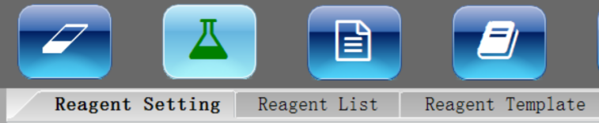
Figure 7.1 Reagent management
- The Reagent Setting screen is used to create and describe reagent types
- The Reagent List screen is used to manage the actual inventory of reagents and register the system reagents.
- The Reagent Template screen is used to create marker groups to allow quick addition of standard diagnostic markers set for the case.
Note: Wear gloves when handling reagents and opening reagent containers. The reagent container may tip during transportation, which may cause the reagent to adhere to the reagent cover.

7.1 General description of reagent management
- It is required that the actual quantity of reagent and detection system in 7ml and 30ml containers should be enough for the slide operation procedure in the processing module. To use the reagent, the details of the actual amount of reagent must be added to the "Reagent list" of the software.
- The system is equipped with a variety of predefined reagents. Other primary antibodies and ancillary reagents may also be added. The process of adding the reagent list to the system is called reagent registration. Users need to register all new reagents, so that the system list can show the total storage of all reagents.
- After a reagent is used, the system will calculate the remaining amount. In addition, for system-provided reagents, you can enter the storage volume when necessary to order more reagents.
- Before registering a reagent, the software must obtain details of the reagent, such as reagent type and supplier. These details are entered on the Reagent Settings screen. A complete reagent list is installed in the system. Other reagents, detection system, and open containers for titration reagents must be added and registered before use.

7.2 Reagent identification
Each reagent container is individually identified by a unique number called a “unique package identifier” (UPI). When you register the reagent into the system, UPI is read into the software when manually entering the reagent package IDs.
You can register the reagents into the detection system at any time by using the “Input ID” button on “Reagent List” screen, to open “Reagent Barcode Verification” box, here you can enter UPI and click the “Verification” button. If the system finds the reagent or reagent kit in the database, all information related to it will be displayed.

7.3 Substitute reagent
A sufficient quantity of all required reagents must be loaded into the processing module before the processing starts. This ensures that batch slides can be run completely without running out of reagent. Occasionally a certain reagent is not available when needed. This may be because a reagent tray has been removed from the processing module or the actual volume of the reagent container is less than the amount initially detected. If this happens, the system will give visible and audible alerts and will attempt to substitute the missing reagent with the same type of reagent from another container.
When substituting an unavailable reagent, the system uses the following rules:
- If the system detects two containers of the same reagent from one detection system, it will first use the reagent of the same type with the smaller volume or the one with the closest expiration date. If successful the batch will continue without warning.
- The system will then attempt to substitute the missing reagent with the same optional reagent type and lot number. If successful the batch will continue without warning.
- The system will then try to use the same type, but a different lot number of optional reagents to substitute the missing reagents. If successful, the batch will continue, but affected slides will be notified of the event.
- If reagent substitution is not possible, a large reagent will be used to replace the missing reagent for the entire reagent distribution of the affected slides until the end of the batch. Batch slide operation will continue, but affected slides will be notified of the event.
- If all slides are affected and need to be replaced with a large reagent, the slides will be abandoned.

7.4 Determine reagent volume
The system uses two methods to determine the reagent volume: one is to calculate according to the initial reagent quantity, and the other is to use the liquid level induction (LLS) system to determine the reagent capacity by immersion container.
The calculation of reagent volume depends on the initial reagent volume. This method is very accurate for the detection system components and system reagents, because the containers have been accurately filled during the manufacturing process. However, if the reagent splashes out, a large amount of reagent evaporates or the reagent is used in other systems, errors will occur. The amount of reagent in the open container of the system depends on the accuracy of the refilled information, and is also affected by the errors caused by overflow, evaporation and system usage like the reagents and system components.
The LLS system was incorporated into the aspirating probe. When the aspirating probe extends into the container, the LLS system determines the reagent quantity by detecting the reagent height.
The LLS capacity determination (commonly referred to as "dive test") is used when the system has reason to query the calculated capacity. This method is not used frequently to avoid unnecessary system delay.
The dive test is only used when the batch slides are started without delay. This occasionally indicates that a reagent used for a predetermined batch of slides was initially considered available, but was later shown to be insufficient. When this happens, a warning will be issued and the user must refill the container (open container only) or make sure that a suitable reagent is available.

7.5 Reagent list details report
You can generate a report on the detailed information of reagent list displayed in the table. The report output can be controlled by the Detail Report button in "reagent list screen". The generated report shows the information of various visual reagents, including the total remaining amount.
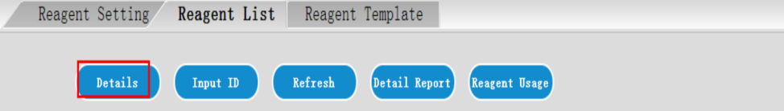
Figure 7.2 Details button for a selected reagent
Click Details (see figure 7.2) or double click a reagent in the reagent list. The report is generated and displayed in a new window, see figure 7.3.
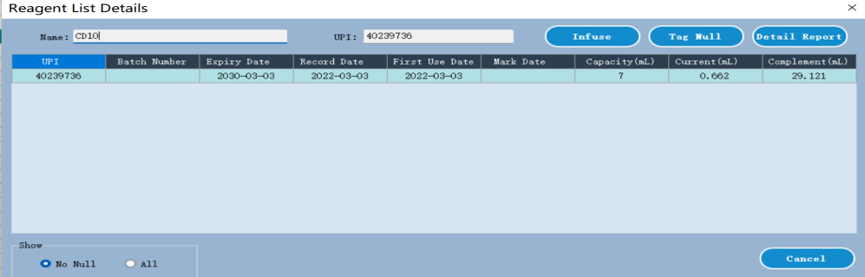
Figure 7.3 Reagent List Details dialog box
Under the reagent list details dialog box, you can infuse the open reagent when the system gives you a notification that indicator the open reagent is not enough. Please follow the below steps to infuse an open reagent again.
1. Click “Infuse”, then input the expired date of the open reagent, click OK to inform the system.
2. Pop up the reagent tray, add a proper open reagent solution into the corresponding open container.
3. Load the reagent tray again, the system will detect reagent volume and update the remaining volume into the database.

7.6 How to register reagent into the system
There are three types reagents, open reagent, auxiliary reagent, Probe reagent, which need to manually add into the system under Reagent management screen. See the figure 7.4. For other types reagents, you only need to follow the below step2 to input the UPI of the reagent into the system, such as detect system reagent, probe cleaning system reagent. The system will bind them with build-in reagent types.
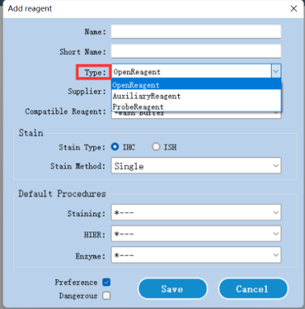
Figure 7.4 Reagent type
Below steps show how to add an open reagent (primary antibody) into the system:
Step1. Use the Admin account to login the system, then click “Add” under Reagent Setting screen to open “Add reagent” dialog box. See the below figure. Such as add primary antibody Ki-67 into the system. The reagent name and short name must be input. Correctly set the staining type. Default procedures settings will bind some default protocols which also can adjust them when creating a slide. The Click “Save” to store the settings.
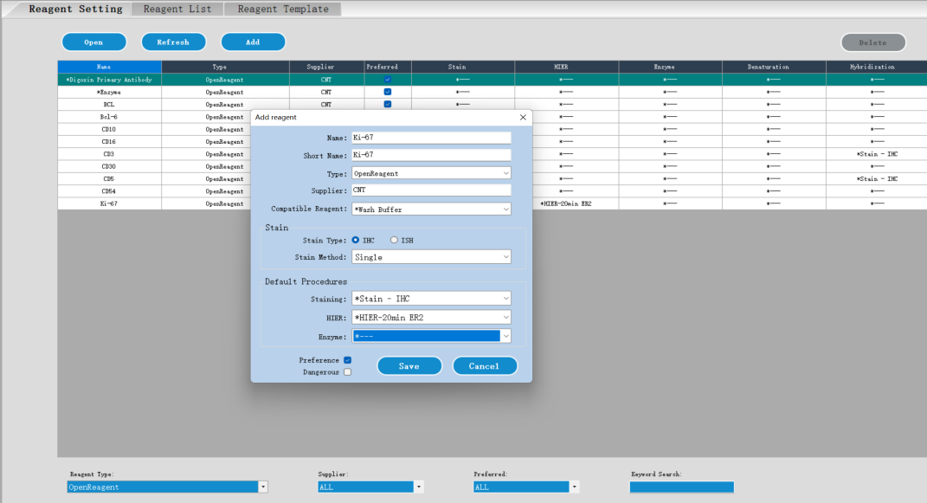
Figure 7.5 Add reagent
Step 2. Bind an open container with the Ki-67 open reagent. Access the Reagent List screen, click “Input ID” to open the “Reagent Barcode Verification” dialog box.
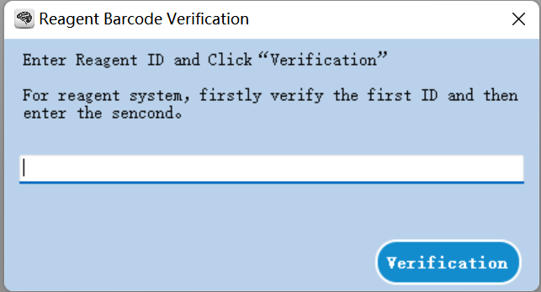
Figure 7.6 Reagent Barcode Verification
Step 3. Input the ID (there is a long ID more than 30 bits on the open container) of the open container to identify the ID of the open container. Once the system verifies the ID, an “Add Reagent” dialog box will display.
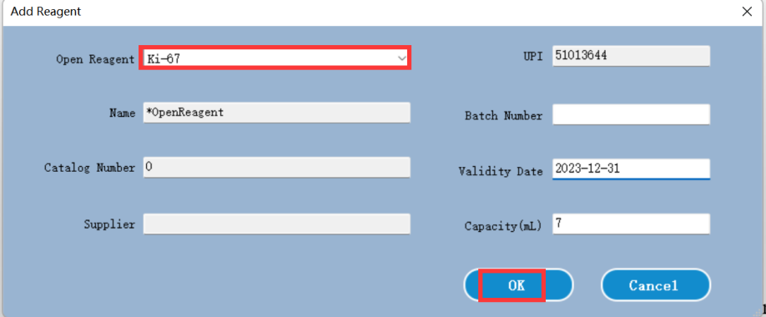
Figure 7.7 Bind an antibody reagent with an open container
Select “Ki-67” under the Open Reagent drop-down list, which you add in the step 1. Then click “OK” to active the settings.
For an auxiliary reagent, click the “Open reagent” area on the pop-up window to open an option list, select “Auxiliary reagent” to bind an auxiliary reagent with a appointed open container.
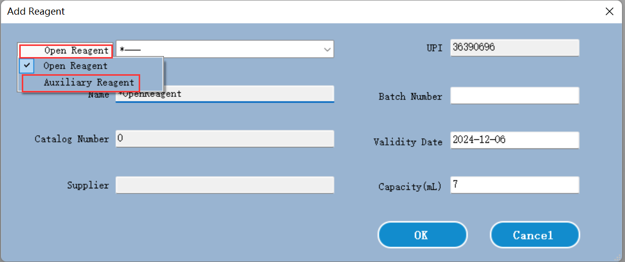
Figure 7.8 Bind an auxiliary reagent with an open container
Detection system reagent kit
For detection system reagent kit, there are two bar-codes, input the two IDs（there are two long IDs on the package box) , Then click “OK” under the pop-up window to add the detection system kit into the system. Refer to the below pictures.
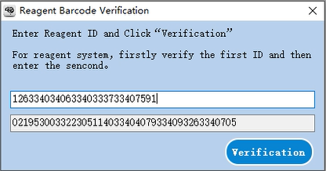
Figure 7.9 Detection system reagent kit register

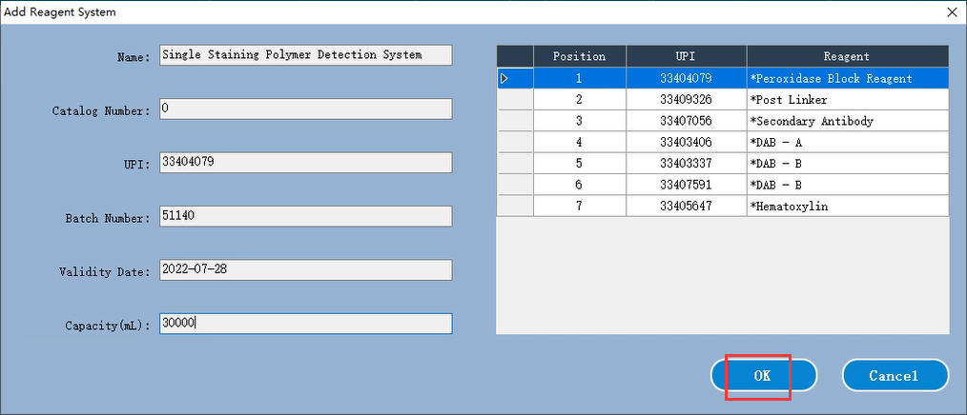
Figure 7.10 Detection system reagent kit register detail

7.7 How to refill an open reagent container
You can reuse the open reagent containers to dispense up to 30 mL of a particular reagent. There is no limit on the number of times containers can be refilled if you fill with quantities less than the container volumes.
Under the reagent list details dialog box, you can infuse the open reagent when the system gives you a notification that indicator the open reagent is not enough. Please follow the below steps to infuse an open reagent again.
1. Click “Infuse”, then input the UPI of the open reagent container which need to fill, set an expiration date for the new reagent, click OK to inform the system.
2. Remove the reagent tray, add the desired volume of reagent into the corresponding open container.
3. Load the reagent tray again, the system will detect reagent volume and update the remaining volume into the database.
※The infuse button will not be available if putting more reagent into the container will exceed the 30 mL limit.
※Note that when infusing an open container, the system assumes that the container is filled to the maximum available for that container. The reported volume will be updated after a dip test is carried out. This may not occur until the container is used.

7.8 Reagent usage report
The reagent usage report shows the amount of reagent used and the number of slides treated with the reagent within the specified time. The report contents are listed in detail by a single container and the total reagents are displayed.
The report includes all reagents used within the specified time, regardless of whether the reagent is currently displayed on the "reagent list" screen, but does not include the use of the detection system.
Click “Reagent usage” to open the date selection dialog box, where you must set the time interval to be covered by the report, and then click OK to generate and display the report in a new window.
The time interval information that you select is displayed in the upper right corner of the reagent usage report.
For each reagent used during this period, the report will show:
- Name (abbreviated name of reagent);
- UPI of each container used;
- Batch number of each container used;
- Expiration date of each container used;
- Usage date each time
- Number of slides processed each time
- The reagent capacity used each time `
Click the print icon to print the report using the selected printer.

Reagent list details report
Click “Detail Report”, the system will generate a reagent list details report.
The filter condition information is displayed in the upper right corner of the reagent list report.
For the various reagents listed in the table, the body of the report will display:
- Name
- Type: Open Reagent or Staining Polymer Detection System, etc.
- Supplier
- Total stock quantity
- Catalog number (for detect system reagent or washing system)
- UPI
- Batch number
- Expiry date
- Record Date (Date of registration)
- First use date
- Last use date
- Remaining capacity
Click the print icon to print the report using the selected printer.

8. Operating protocol management

8.1 Protocol management Screen
In the software, protocols are the series of steps carried out to staining tissue samples. The protocols are templates predefined in the software that cannot be edited or deleted. These protocols have been strictly tested and validated by Celnovte Laboratory. They are known to produce an excellent staining result when used correctly. There are different types of protocols, for the different techniques to be executed (IHC, ISH, etc.), there protocols can be edited, copied to create a new protocol, you can create it from scratch or copy an existing protocol and modify it according to your requirements.


8.2 Protocol Details
When you select a protocol from the list on “Protocol management” screen, double-click it to open a “Edit the protocol”. as the below figure.
The “Edit the protocol” properties dialog displays the following protocol information.
Name: a full name of the protocol.
Protocol Type: cannot be changed.
Short Name: an abbreviated name, used such as on slide labels.
Stain Type: The function of the protocol
Description: comments about this protocol
CNT: display the allowable steps and reagents.

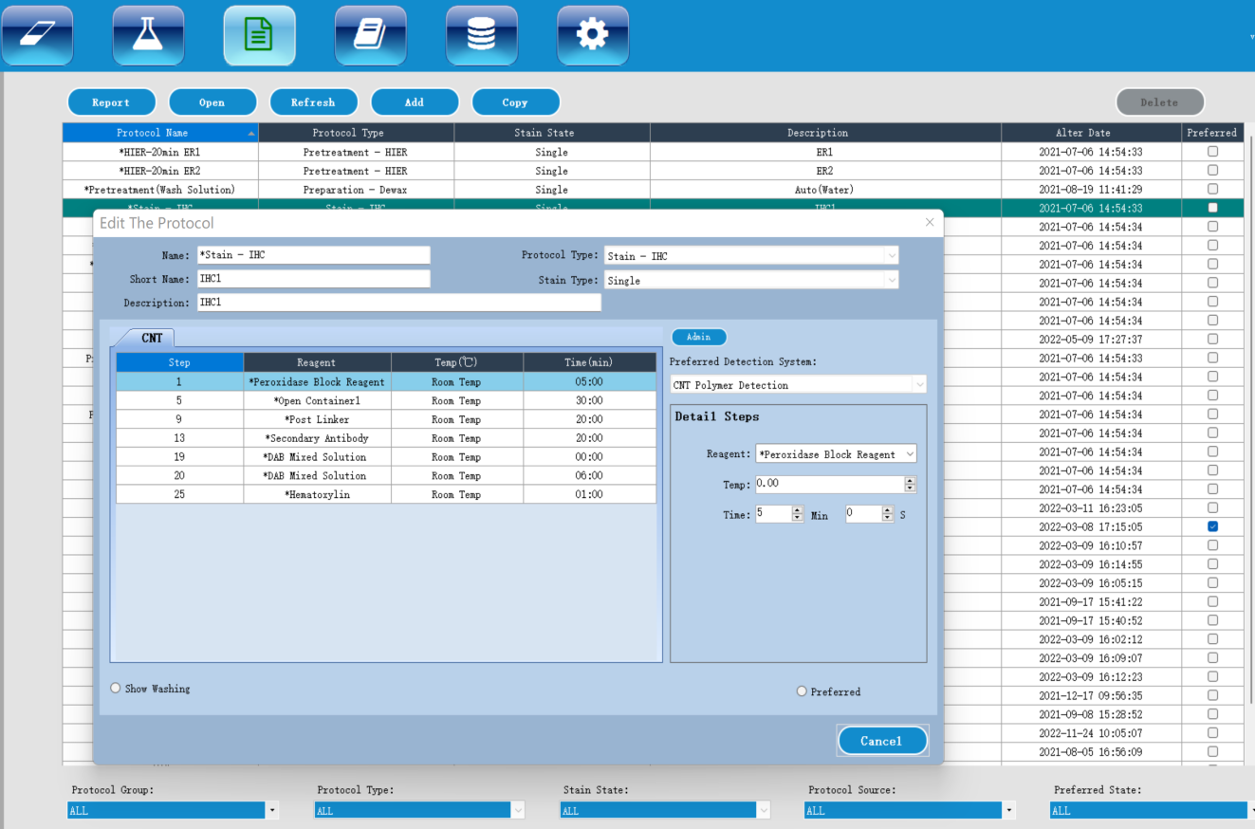
Figure 8.1 Protocol management

8.3 Creating a new protocol
You can click “Add” to create a new protocol. The new protocol will require a unique name and short name.
Then input your own protocol steps according to the stain type.
After editing, click “Save” to add it into the protocol list.

8.4 Copy a protocol
To copy a protocol, select it from the list in the protocol list, then click the “Copy” button. A “New Protocol Properties” dialog box will display. Here please change the “Name” and “Short Name” or you can adjust the details steps to create your own protocol.

9. Slide history screen
To see slide history details. Here you can get some reports, such as “Case Report”, “Protocol Report”, etc.
The slide history list displays the slides run in the period defined in the date range filter. Default display slides history of the current day. Or a special slide found from the Barcode / DeviceName / CaseName filters.
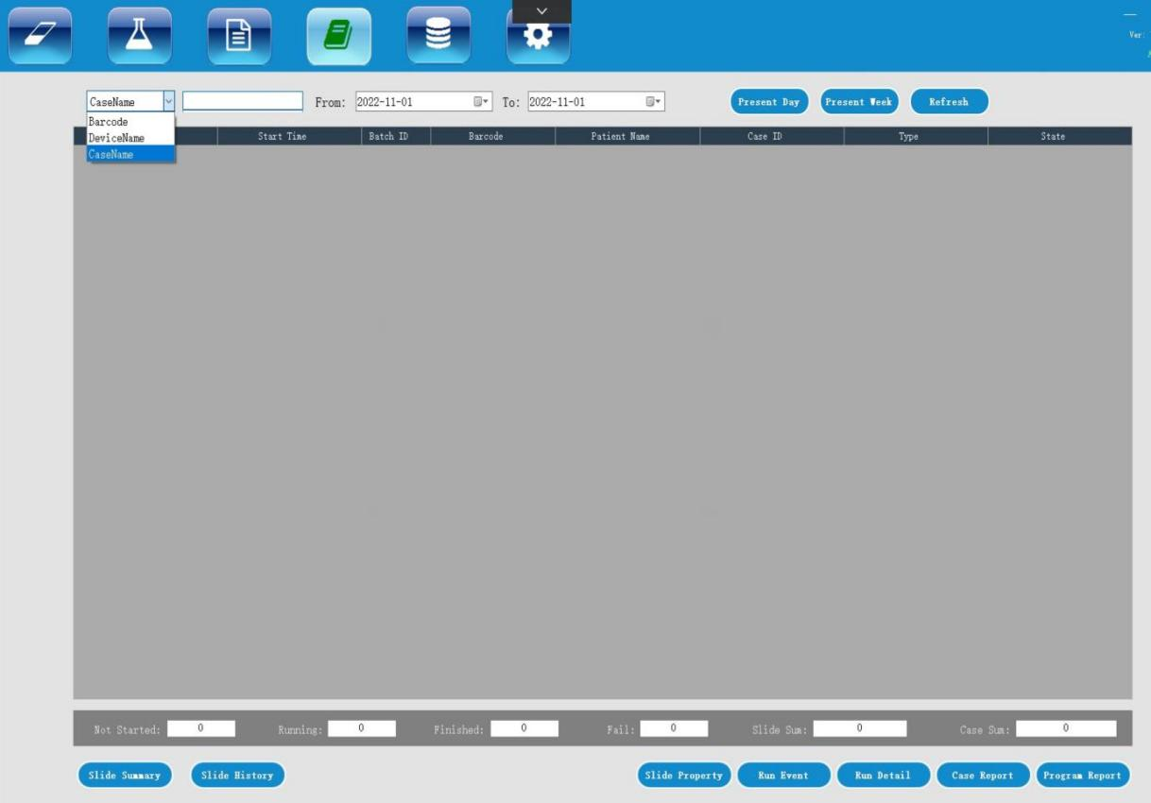
Figure 9.1 Slide history screen

10. Running information
Here real-time displays the detailed running information. This is used for the instrument service personal.
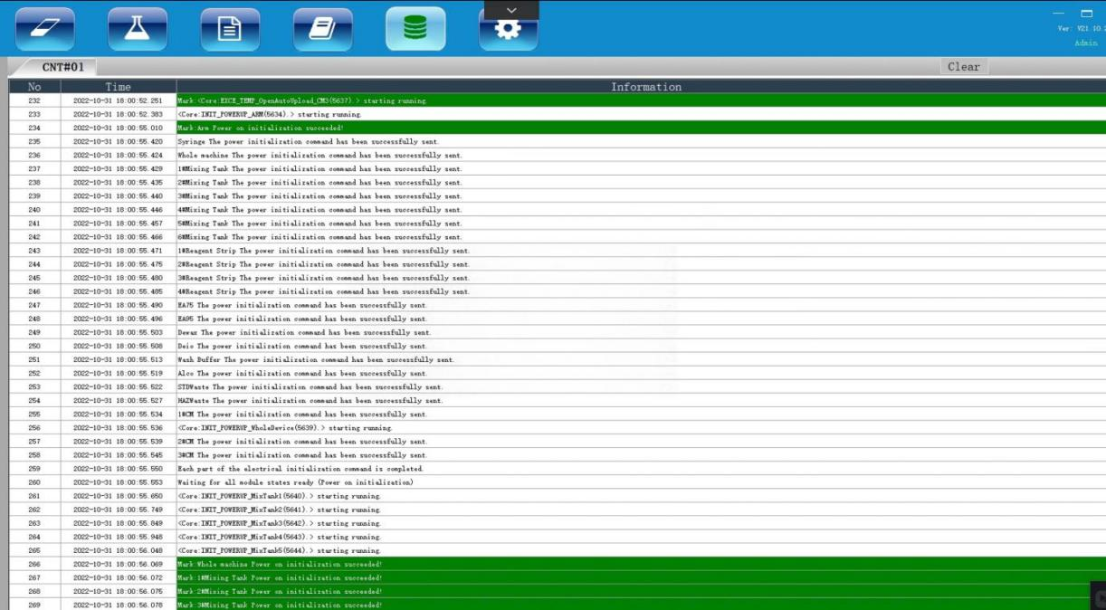
Figure 10.1 Running information

11 Other software operations

11.1 System management screen
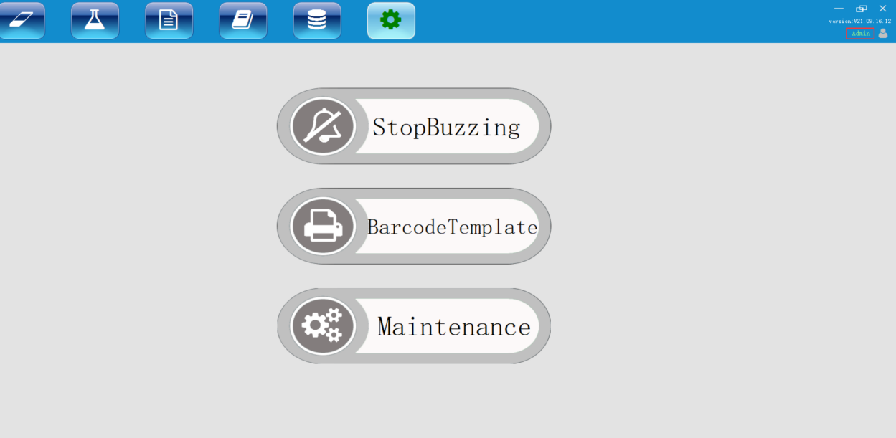
Figure 11.1 System management under Admin account

11.1.1 Turning off the buzzer
When the system detects an error and gives a sound alarm. The operator can turn off the buzzer by clicking “StopBuzzing” button on the Maintenance screen.

11.1.2 Set slide label template
Click “BarcodeTemplate” to check the default slide label template. Under “Slide Label Editor” dialog box, click “File”- “Open” to select a default slide label.
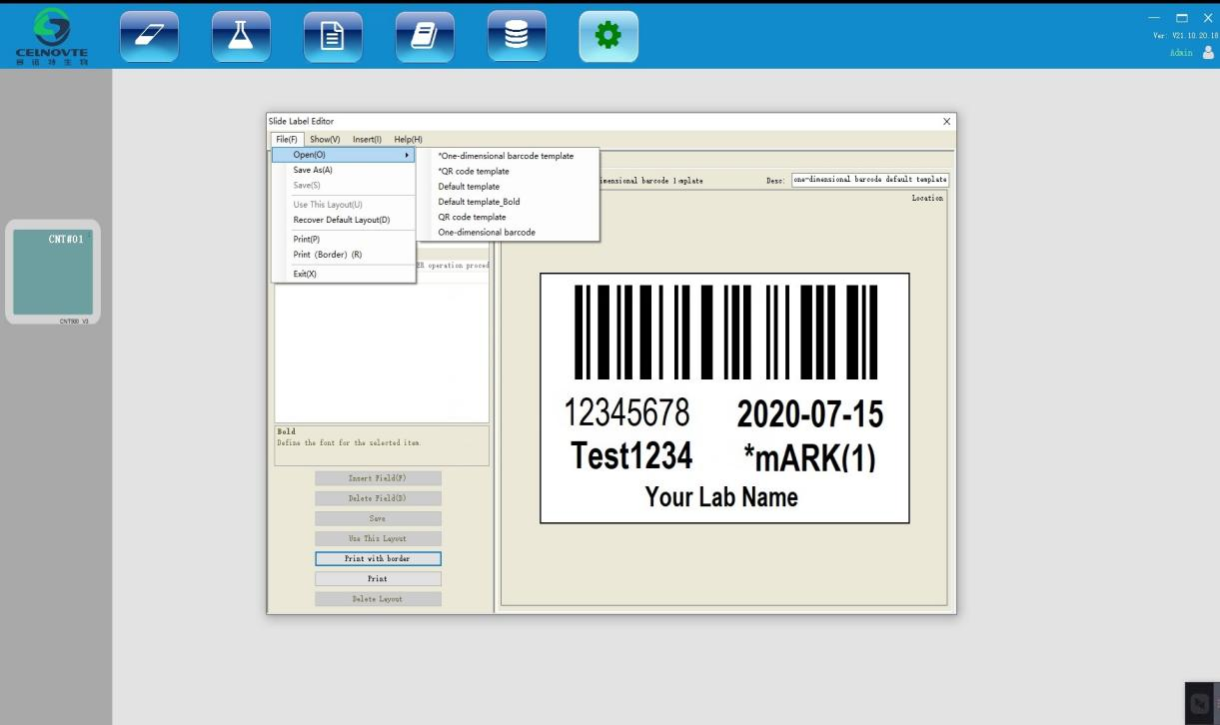
Figure 11.2 Slide label template
Please note, do not edit the template which name starts as a “*” mark.

11.1.3 Perform the maintenance tasks
When need to do the maintenance tasks, please click the commands button. Such as, Water Washing Probe, Reagent Washing Probe, Replace Probe and Replace Syringe. Detailed information, please check the “Cleaning and maintenance” chapter.

12. Cleaning and maintenance

12.1 Precautions

Warning:
When performing cleaning or maintenance tasks, please power off the processing module (except for cleaning the aspirating probe or cleaning the high-volume liquid flow automatic control device).

Warning:
Hazardous liquids may collect around various parts of the processing module. Always wear protective clothing and gloves when using the processing module and its components (including reagent containers). Remove spilled solution immediately according to standard laboratory specifications.

Warning:
The temperature of the slide staining tray unit in the machine may be very high and cause serious burns. Do not touch the slide staining tray unit or its surrounding area within 20 minutes after the processing module stops working

Note:
Only clean by hand all removable components. To avoid damage, do not use automatic dishwasher to clean any components; Do not use solvent, strong or abrasive cleaning solution or rough or frosted fabric to clean any parts.

- Every time you use the machine, check for leaks, wear or damage. If there are instructions for repairing or replacing worn or faulty parts in this chapter, follow these instructions; otherwise, please contact customer support.

12.2 Cleaning and maintenance schedule
Task | chapter
Daily – when the daily work starts
Check that the low concentration waste liquid container is not more than half full *
Check that the large reagent container should be more than half full and filled with the correct reagent*
Daily - at the end of daily work
Clean the liquid cover | 12.6
Weekly
Clean the slide staining units * | 12.4
Check the liquid cover clamps | 12.5
Restart the processing module | 12.18
Clean the aspirating probe of the main automatic control device | 12.3
Check washing area and mixing station, clean or replace if necessary | 12.9
Clean the instrument surface, instrument door and instrument cover | 12.8
Clean scanning module | 12.14
Clean the drip tray | 12.10
Monthly
Replace the mixing station | 12.9
Clean the large reagent container | 12.12
Clean the low concentration waste liquid container | 12.13
Clean slide trays | 12.7
Clean slide label printer | 12.15
Check the syringes | 12.16
Every three months
Wash the aspirating probes by the reagent cleaning kit | 12.3
When necessary or least a year
Replace the aspirating probe of the main automatic control device | 12.3
Replace the syringes | 12.16
*If necessary, increase the frequency of these tasks.

12.3 Aspirating probe

Figure 12.1 Schematic diagram of aspirating probe device

12.3.1 Clean the probe
Normally the probe is automatically cleaned in the wash area after touching each reagent as part of normal operation. However additional weekly cleaning should be carried out.
After powering off the processing module, use a soft cloth soaked in 70% alcohol solution to carefully wipe the exterior of the aspirating probe. Check the tube to ensure that there is no object inside the tube, and the tube should be kept clean.
When need to wash the probe, please follow the below steps to perform:
Click “Maintenance” button on system management page, “Water Washing Probe” is only used when fluid flow system needs to clean, refer to “Cleaning fluid flow system part under 12.18 Restart the processing module”.
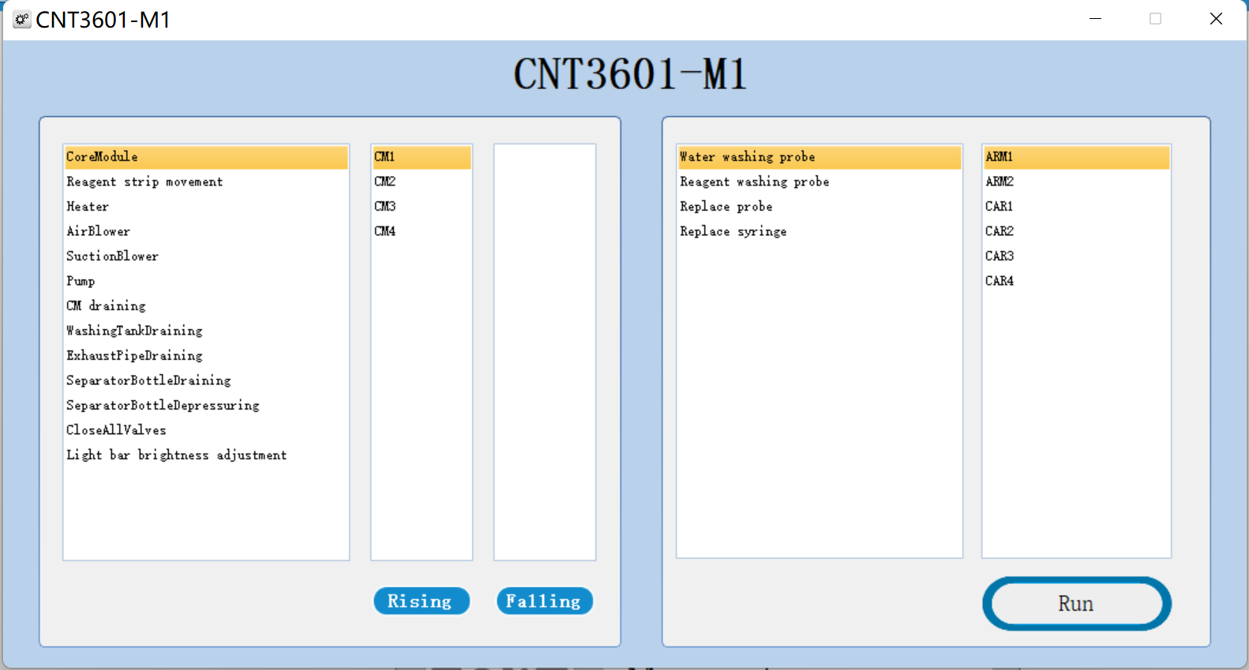
Figure 12.2 Maintenance operation
Every three months, please follow the below steps to perform the “Reagent washing Probe” with Celnovte probe cleaning kit.
1, Register the Celnovte probe cleaning reagent kit into the system.
2, Ensure that the processing module is idle, with no runs loaded or processing.
3, Remove all reagent or reagent kits from reagent platform.
4, Insert the Celnovte probe cleaning reagent kit into the reagent kit.
5, Click the button “Reagent washing Probe” to run the probe clean.
6, Wait until notified that the clean is finished.
7, Remove the Celnovte probe cleaning reagent kit from the reagent platform.

12.3.2 Replace the probe
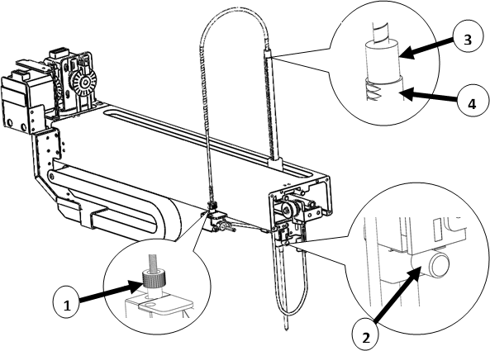

Figure 12.3 Aspirating probe assembly
Replace the aspirating probe
To remove the aspirating probe assembly, proceed as follows:
1. Make sure that the processing module is idle and there are no slides loaded, scheduled or running.
2.Start the replacement by clicking the replace aspirating the corresponding probe button in the maintenance screen.
3. Read the instructions in the Replace aspirating probe dialog box carefully, and then click OK to continue.
4. The system starts to prepare the flow system for replacing the aspirating probe.
When the flow system is ready (this may take some time), the processing module is disconnected from the software.
5. Close the processing module switch and open the instrument cover.
6. Wipe the probe needle with a paper towel to dry the liquid or droplet.
7. Completely loosen the thumb screw at the rear of the level sensor block (as shown in Figure 12.3 No. 2).
If the thumb screw is not completely unscrewed, the PTFE coating on the aspirating probe may be damaged.
8. After the probe is loose, pull the pipe upward through the aspirating probe bracket to take out the probe assembly.
9. Unscrew the aspirating probe connector (No.3 in Figure 12.3) off the rigid coupling.
Install a new aspirating probe
The installation of aspirating probe is a key operation. If the probe is not installed correctly, the staining quality of the instrument will be affected. If you have any concerns about doing this, please contact customer support.
Install a new aspirating probe assembly as follows, taking care not to damage the needle:
1. Check that the aspirating probe holder is fully raised.
2. Carefully remove the new aspirating probe from the protective packaging.
3. Tighten the aspirating probe connector and the rigid tube connector.
4. Insert the aspirating probe from the top of the aspirating probe holder until the shoulder of the aspirating probe connector coincides with the top of the aspirating probe holder (as shown in 3 and 4 of Figure 12.3), and then stop.
If the probe does not enter smoothly, check whether the thumbscrew has been loosened, and then reposition the probe until it slides in, no force should be used.
5. While still holding the aspirating probe, tighten the thumbscrew (2 in Figure 12.3) on the back of the liquid level sensor block until the fingers cannot move.
Do not over tighten as this will damage the aspirating probe.
Carefully check whether the aspirating probe can rotate or move up and down. The aspirating probe should not be able to rotate or move up and down.
Observe the probe from the front and side, making sure it is perpendicular to each horizontal plane. If the probe is not vertical, loosen the thumbscrew and check again that it is positioned correctly. If the probe is still not vertical, that is, bent, a new probe should be used.
6. Make sure that the aspirating probe holder is fully raised, and then turn on the processing module, When the processing module starts up, the system will be primed. Please check the connection to ensure that there is no liquid leakage when the system is primed.
7.After replacing the aspirating probe, click Yes in the confirmation dialog box. If you are not sure if the new aspirating probe is installed correctly, click No and contact customer support.
8. To confirm that the new aspirating probe is installed correctly, run the test tissue or control tissue to see if proper staining can be achieved.

12.4 Slide staining units
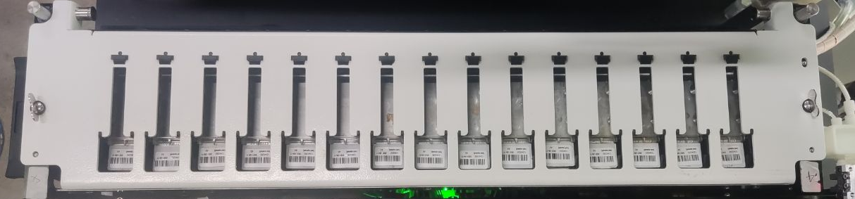
Figure 12.4 slide staining unit

 Warning：
The processing module has heater and heating surface. If inflammable substances are placed nearby, there may be a risk of ignition:
- Do not place flammable materials on or near the heater.
- Do not place flammable materials on any hot surface of the processing module.
- After refilling or emptying large containers, make sure that all containers are tightly covered.
Warning:
The slide staining assembly and its surroundings, as well as the slides in the slide staining assembly, may be very hot, which may cause serious burns if contacted.
Do not touch the slide staining assembly until the software indicates that the temperature is low. If the software is not running, wait at least 20 minutes after switching off the power supply of the processing module.
Note:
Before cleaning or maintaining the slide staining assembly, please make sure that the processing module has completed any operation and turn off the power supply.

12.4.1 Cleaning
1. To clean the slide staining unit, wipe the cover plate, liquid cover fixing clamp and washing plate with a dust-free cloth and 70% alcohol solution. To gain access to the cap holder and dish, you need to release and rotate the cap as described in 12.4.2 "Remove the cover plate" below. It is not necessary to remove the cover completely when cleaning.
2. When cleaning the slide staining unit and its components, please check for deformation and permanent damage. The deformed cover plate should be replaced, because the deformation of the cover plate will affect the fixing effect of the slide, thus affecting the staining quality. If there is any damage to the slide staining assembly components, please contact a service representative.
3. After cleaning the cover plate, close the cover plate and check whether the holes on both sides of the cover plate are correctly engaged with the locating pin. Press and hold the cover and turn the fastening bolt clockwise. The cover plate shall be firmly fixed after a right angle is turned clockwise.
12.4.2 Remove the cover plate
To remove the cover plate, proceed as follows:
1. Press and hold the cover and turn the fastening bolt counterclockwise to open the cover. Turn the cover back around the shaft head, as shown in Figure 12.5.
2. Pull the hinge buttons with spring at both ends of the cover plate and lift the cover plate from the glass plate staining device to remove the cover plate, as shown in Figure 12.6.
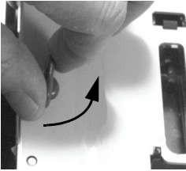
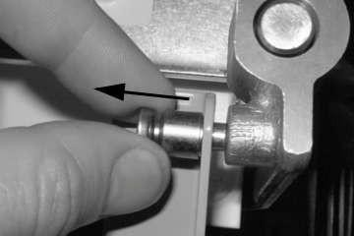
Figure 12.5 Turn the fastening bolt
Figure 12.6 Pull the spring hinge

12.4.3 Reinstall the cover plate
1. Align the hinge position of the slide staining assembly, put the cover plate in the open position, and then put one of the hinges into the hinge position of the slide staining assembly. The upper end of the cover plate should face away from the slide staining assembly.
2. Pull the other hinge button, put the end of the cover in, and then release the hinge button.
3. Close the cover plate and check that the holes at both ends of the cover plate are engaged with the locating pin correctly.
4. Press the cover and turn the fastening bolt clockwise. The cover plate shall be firmly fixed after a right angle turned clockwise.

12.5 Liquid cover clamp
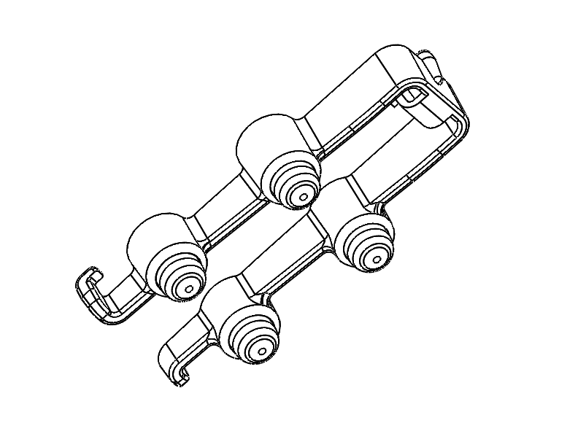
The liquid cover clamp, as shown in Figure 12.7, should be checked at least once a week. If there is any damage or a spring does not rebound after being pressed, please contact your service representative.
Figure 12.7 the liquid cover clamp

12.6 Liquid cover
As long as the liquid cover is not discolored or damaged and the cleaning method is correct, it can be reused for 25 times. To reuse the liquid cover, please carefully check whether there are notches, cracks, bending, deformation or other signs of damage. If the appearance of the liquid cover is not damaged, clean it with 70% alcohol solution. When cleaning, check whether the liquid cover is discolored or damaged. If the liquid cover is damaged or the staining quality drops, discard it. Standard cleaning is as follows:
（1）Soak in 100% IMS (industrial methanol denatured alcohol), ethanol or reagent grade alcohol for at least 10 minutes.
（2）Stir for 30 seconds.
（3）Dry：
Dry with a lint free cloth, or Dry by airing.
（4）Carefully check the liquid cover surface for debris, cracks or deformation. If there is any damage, discard it.

12.7 Slide tray
Clean the slide tray with a 70% alcohol solution. Replace the deformed or damaged slide trays.

12.8 Protective covers and doors
Use a wet, lint free cloth to remove dust from the protective cover and instrument doors to prevent accumulation of dirt. If the protective cover or instrument door is deformed or damaged, please contact your service representative for replacement.

12.9 Mixing station
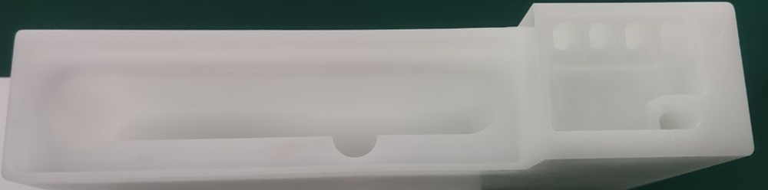
Figure 12.8 Washing area and mixing station
The mixing reagent container in the mixing station should be replaced once a month (based on the utilization rate of 60 slides per day. If more or less slides are used, change the frequency accordingly). The old container can be replaced with a new mixing reagent container. The mixing reagent container should be installed in place (the bottom of the container should contact with the bottom of the round tank of the mixing station).

12.10 Drip tray
To clean the drip tray every weekly, follow the below steps to perform:
- Open the lower right door.
- Pull out the drip tray from the bottom of the instrument. See the figure 12.9
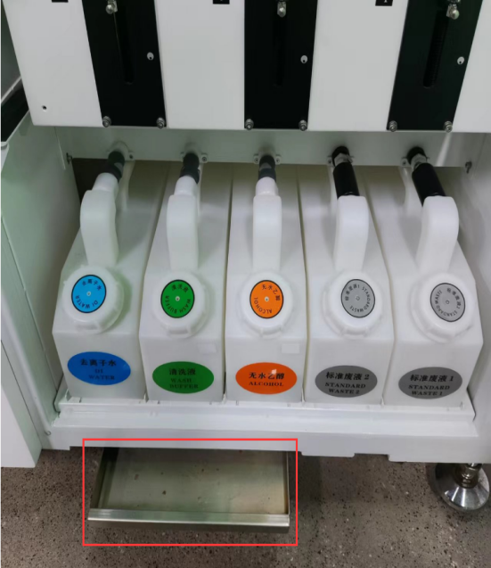
Figure 12.9 Drip tray
- Dispose of the waste liquid according to the operating procedures of your laboratory. Then clean the rack with a 70% alcohol solution.
- Push the drip tray back into the home position.

12.11 Reagent tray
Clean the reagent tray with 70% alcohol solution, and then air dry or wipe it upside down.
Note：
Do not use hot water or hot solvent to clean the reagent tray, and do not use high-pressure heating. Hot water, hot solvents or high-pressure heating may deform the reagent tray.

12.12 Large container

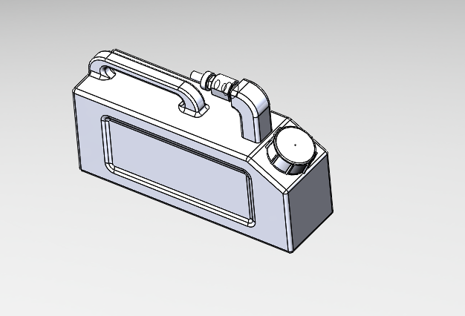
2
1
Figure 12.10: Large container
1 Filling / emptying cover; 2 Interface
For waste liquid, take out the container from the large container rack, open the container cover (1 in Figure 12.10), and treat the waste liquid according to the method of your laboratory.
For large reagents, open the container cover and fill the reagent as needed without taking the container out of the large container rack.

Warning:
Some reagents used in immunohistochemistry and in situ hybridization are harmful, especially chromogenic reagents, which can cause cancer through skin contact. When handling waste liquid containers, please wear gloves and operate carefully.

To fill the large reagent container or empty the high concentration waste liquid container, the operation is as follows:
1. Make sure that the processing module is not running.
2. Open the rack door of the large container.
3. Fill reagent or empty waste liquid.
- For the waste liquid containers, take out the container from the large tank, open the container cover (1 in Figure 12.10), and treat the waste liquid according to the method of your laboratory.
- For large reagents, open the container cover (1 in Figure 12.10) and fill the reagent as needed without taking the container out of the rack.
4. Push the container back into place to ensure a leak free connection.
- Routine cleaning of large reagent container can be done with an industrial grade detergent and rinse with deionized water.
- Clean the reagent container monthly and wash with bleach or industrial strong detergent, and then rinse well with deionized water.

12.13 Waste liquid container
To empty the waste liquid container:
1. The waste container is same with the large container, refer to the 12.12 large container cleaning steps to take out the waste liquid container.
2. Remove the container cover and dispose of the waste liquid according to the operating procedures of your laboratory.
3. Push the container back into place to ensure a leak free connection.

12.14 Robotic arm and scanning module
To clean the robotic arm, soak the cloth with 70% alcohol solution, and then wipe the robotic arm. Avoid rubbing the aspirating probe bracket as this will dissolve the lubricant from the bracket. Also, do not clean the carriage for the robotic arm to move, as this will wipe off the lubricating oil, which may reduce the performance of the processing module.

Note:
When cleaning the robotic arm, please turn off the processing module to minimize the risk of short circuit caused by liquid dripping. Do not use a wet cloth to clean the scanning module, because the residual moisture on the window may cause failure. Do not use alcohol or solvents to clean windows.

Every week, or when the scanning module repeatedly fails to scan the ID correctly, clean the window with cotton swab or lint free cloth dipped in distilled water.

12.15 Slide label printer
A manual is attached to the slide label printer. Refer to these manuals for instructions on cleaning, loading labels and printing tapes.

12.16 Syringe
The syringe pump draws and accurately distributes the amount of liquid required by the system. The plunger forms a fully sealed space in the needle tube. Glass needle tubes and plunger must be free from any damage to ensure accurate aspirating and distribution of liquid. If there is any damage, it must be replaced.
12.16.1 Check the syringe
Check the syringe at least once a week according to the following steps. If there are signs of leakage or if the syringe is loose, contact your service representative.

Note:
Do not use any tools to fix or reinforce the syringe.
1. Make sure the processing module is not running.
2. Open the syringe cover.
3. Check around the connection and underpart the syringe for signs of leakage.
4. Only use your fingers to confirm whether the glass needle tube of the syringe is firmly covered on the plastic valve.
12.16.2 Maintenance
The syringe must be replaced every six months. This can be done by customer service, or you can do it yourself.
12.16.3 Remove the syringe
Follow these steps to remove the syringe:
1. Make sure that all operating instruments are not running and that no batch of slides are loaded, scheduled or running.
2. When the processing module is disconnected, turn off the processing module and the computer.
3. Open the large reagent rack door of the processing module.
4. Loosen the two screws holding the syringe clamp, as shown in Figure 12.11.
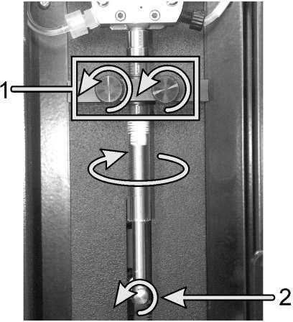
Figure 12.11: Remove the syringe with clamping screw (1) and plunger screw (2)
5. Remove and retain the thumbscrews that hold the plunger to the pull-down arm (see Figure 12.11)
6. Twist the glass tube in the direction shown in Figure 12.11 and pull it out of the syringe valve.
7. Take out the plunger from the glass tube.
8. Remove the syringe clamp (including the inner liner) completely from the glass tube.
12.16.4 Replace syringe
Replace the syringe as follows:
1. Slide the bushing ring the syringe about 10 mm from the metal end cap (see Figure 12.12).
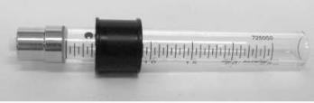
Figure 12.12: Position of syringe bushing
2. Align the top and bottom of the syringe clamp with the bushing (as shown in Figure 12.13), but do not tighten it completely, so that the syringe can still rotate.
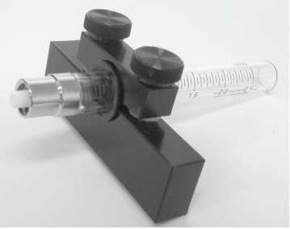
Figure 12.13: Syringe clamp with syringe
3. Clean the plunger with alcohol and wait for the alcohol to evaporate completely.
4. Wet the top of the plunger with deionized water.

Note: If the plunger is not properly treated with alcohol and deionized water as described in the above steps, bubbles may be generated in the system and tissue staining may be affected.
5. Insert the plunger fully into the glass tube.
6. Push the glass tube upward to fix it on the syringe valve, and at the same time turn it one circle in the direction shown in Figure 12.14. Do not use any tools to secure or reinforce the syringe. The connection must be tight or air will seep into the system.

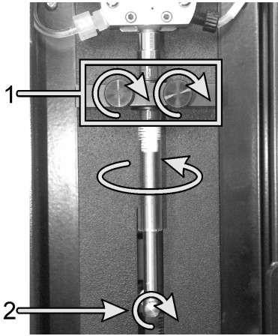
Figure 12.14: Replace the syringe with clamping screw (1) and plunger screw (2)
7. Tighten the two clamping screws (see 1 in Figure 12.14) to secure the syringe tube. The syringe clamp should be about 10 mm away from the metal end cover.
8. Hand-tighten the plunger-to-arm screw (see 2 in Figure 12.14).
9. Close the doors where the syringes are located.
10. Restart the processing module and the computer.
11. Check the processing module for proper filling, and check for bubbles or leaks around the syringe.

12.17 Disconnect the processing module
To disconnect the processing module from the main power supply, follow these steps:
1. Turn off the power by using the switch on the processing module.
2. Locate the wall power along the processing module main power connection cable and unplug the main power supply of the wall socket.
3. Disconnect the plug connection from the back of the processing module.

12.18 Restart the processing module
Each processing module shall be shut down and restarted once a week. This is important because it enables the processing module to perform a system self-diagnosis check.
For the processing module, first confirm that there are no loaded, planned or running slides, then turn off the power switch on the instrument, and wait for 30 seconds before turning it on. Once started, the system primes the liquid flow system and performs a series of system tests.
Note: you can perform a partial flow system prime without turning off the power of the processing module (refer to the following cleaning fluid flow system).
Cleaning fluid flow system
Press “Water Washing Probe” button in the maintenance screen to prime the fluid flow pipeline of the large container (this is part of the initialization operation when the processing module starts). Perform this routine maintenance if you suspect a blockage or bubble in the flow delivery system.
1. Make sure that the processing module is idle and there are no slides loaded, scheduled or running.
2. Click the “Water Washing Probe” button in the maintenance screen to start cleaning. When prompted to confirm, click Yes. The flow system is then primed, which takes several minutes.

13. Technical parameter

13.1 Physical specifications

Dimensions | CNT360-M1：  Width-1370mm(53.94in)  Depth-820mm(32.28in)  Height-1600mm (62.99in)
Weight | CNT360-M1：600KG
Space requirements | Upper 600mm (23.62in)  Left 400mm (15.75in)  Right 200mm (7.87 in)  Behind 300mm (11.81 in)  However, the user must be able to disconnect the main power cord without moving the instrument.
Maximum distance from liquid waste container | Place them in the bottom cabinet of the instrument
Service life | 5years

13.2 Electric
Working voltage and power frequency | AC220V / 50Hz
Power consumption | 2800 VA

13.3 Environment
Maximum operating temperature | 35°C（95°F）
Minimum operating temperature | 5°C（41°F）
Temperature required to meet staining operation standard | 18-26°C（64-79°F）
Working humidity | 10~80%RH (no condensation)
Maximum working altitude | 0~1600 m（5250ft.）Above sea level
Sound pressure level output (at 1m) | <65dB
Maximum thermal output | 2800 VA

13.4 Operating Specifications
Slide handling capacity | 60 slides each time, 4 trays, 15 slides each tray,  Finished trays may be replaced continuously.
Reagent container capacity | 5mL, 10mL,25mL and 40mL. You can also refer to this setting and adjust the sample volume according to actual needs
Invalid capacity of reagent container | 350μL
Number of small reagent containers | 70
Large reagent container capacity | 4L
Hazardous waste container capacity | 4 L
Standard waste container capacity | 4 L
Chemical compatibility | Standard reagents for all systems  70% alcohol solution
Temperature indication | Default value (can be changed by a service representative):  warm：37°C；hot：80°C

13.5 Microscope slides
Size | Width:24.64-26.0mm (0.97 - 1.02 in)  Length:74.9-76.0mm (2.95 - 2.99 in)  Thickness:0.8-1.3mm (0.03 - 0.05 in)
Label area | Width:24.64-26.0mm (0.97 - 1.02 in)  Length:16.9-21.0mm (0.67 - 0.83 in)
Material | Glass, ISO8037/1
Available area | Refer to Figure 3.13 and 3.14, the allocated capacity refers to the setting value that can be selected when using the software to set the slide.

13.6 Transportation and storage
Storage temperature | -20 to +40°C (-4 to +104°F)
Storage humidity | 10~80%RH (no condensation)
Type of shipping | Road, sea and air freight compatible.

Version information
Revision | Issued | Main change | Description
V1.0.0 | December.2022 | Various | Adding how to refill an open reagent container. etc..
V1.0.1 | December.2023 | 4.2  7.6 | User access right modification  How to register auxiliary reagent .
V1.0.2 | May. 2024 |  | A few modifications
V1.0.3 | July.2025 |  | Modified EC REP symbol to EU REP
V1.0.4 | February.2026 |  | Add delayed start feature  A few modifications

After-sales service commitment
All Fully automatic IHC&ISH staining system ordered from our company have 12 months free after-sales service (except for human damage not in accordance with the instruction). Our company provides lifelong after-sales maintenance service, and the fee may be charged according to the actual situation.
Interpretation of graphics, symbols, abbreviations, etc. used in medical device label
Signs and description
 | Caution! Indicates the need for user to consult the instructions for use for important cautionary information.
 | Consult the instructions for use
 | In vitro diagnostic equipment
 | Recycling and waste disposal. This product must be treated  in accordance with the regulations for the disposal of  electrical and electronic equipment waste. Disposing of your  old equipment in the correct way will help environmental  protection and reduce health hazards.
 | CE Mark
 | Manufacturer
 | Authorized representative in the European Community
 | Indicates that the transport package contains fragile items, and should be handled carefully
 | Indicates that the transport package should be upright during transportation
 | Indicates that the transport package is afraid of rain
 | Protective ground terminals
 | alternating current
 | Date of manufacture
 | Serial number
 | Use-by date
 | Temperature limit
 | Batch code

Basic information

Manufacture：Henan Celnovte Biotechnology Co., Ltd.
Address：NO.1 Cuizhu Street, Bldg.109, Hi-tech District, Zhengzhou, Henan, China.
Post code: 450000
Tel: +86 371-56596916
Mail: service@celnovte.com
Website: www.celnovte.com

Umedwings Netherlands B.V.
Address：Treubstraat 1, 2288EG, Rijswijk, The Netherlands
E-mail：info@umedwings.com

